ANNUAL PROGRESS REPORT 2012-13
KRISHI VIGYAN KENDRA, TIKAMGARH (M.P.)
IN ZONE VII

Contents
Sl. No. | Particular | Page No
1 | General Information | 2-7
2 | On Farm Testing | 8-13
3 | Achievements of Frontline Demonstrations | 14-21
4 | Documentation of the need assessment conducted by the KVK for the training programme | 22
5 | Training programmes | 23-28
6 | Extension Activities | 29-30
7 | Literature Developed/Published (with full title, author & reference) | 31-34
8 | Production and supply of Technological products | 35-36
9 | Activities of Soil and Water Testing Laboratory | 37
10 | Rainwater Harvesting | 37
11 | Utilization of Farmer Hostel facilities | 38
12 | Utilization of Staff Quarter facilities | 38
13 | Details of SAC Meeting | 39
14 | Status of Kisan Mobile Advisory | 39
15 | Status of Convergence with agricultural schemes | 40
16. | Status of Revolving Funds | 40
17. | Awards & Recognition | 41
18. | Case study and Success story | 41
19. | Details of KVK Agro-technological Park | 42-43
20. | Important visitors to KVK | 43
21. | Status of KVK Website | 44
22. | Status of E-connectivity | 44
23. | DETAILS OF TECHNOLOGY WEEK CELEBRATIONS | 44
24 | INTERVENTIONS ON DROUGHT MITIGATION | 45-47
25 | Status of KVK Website | 47
26 | Well labeled Photographs | 48-49

REPORTING PERIOD – April 2012 to March, 2013

Summary of achievements during the reporting period
KVK Name | Activity | Target |  | Achievement
KVK Name | Activity | Number of activity | No. of farmers/ beneficiaries | Number of activity | No. of farmers/ beneficiaries
Tikamgarh | OFTs | 25 | 125 | 25 | 125
Tikamgarh | FLDs – Oilseeds (activity in ha) | 02 | 24 | 02 | 24
Tikamgarh | FLDs – Pulses (activity in ha) | 02 | 24 | 02 | 24
Tikamgarh | FLDs – Cotton (activity in ha) | - | - | - | -
Tikamgarh | FLDs – Other than Oilseed and pulse crops(activity in ha) | 08/Ha | 85 | 08/40 Ha. | 85
Tikamgarh | FLDs – Other than Crops (activity in no. of Unit/Enterprise) | 08 | 88 | 08 | 89
Tikamgarh | Training-Farmers and farm women | 64 | 1600 | 64 | 1789
Tikamgarh | Training-Rural youths | 07 | 175 | 07 | 182
Tikamgarh | Training- Extension functionaries | 10 | 250 | 11 | 255
Tikamgarh | Extension Activities | 27 (08) | 3684 | 27 | 3684
Tikamgarh | Seed Production (Number of activity as seeds in quintal) | - | - | - | -
Tikamgarh | Planting material (Number of activity as quantity of planting material in quintal) | - | - | - | -
Tikamgarh | Seedling Production (Number of activity as number of seedlings in numbers) | - | - | - | -
Tikamgarh | Sapling Production (Number of activity as number of sapling in numbers) | 25000 | 100 | 27000 | 105
Tikamgarh | Other Bio- products | - | - | - | -
Tikamgarh | Live stock products | - | - | - | -
Tikamgarh | SAC Meeting (Date & no. of core/official members) | 02 | 50 | 02 | 50
Tikamgarh | Newsletters (no.)
Tikamgarh | Publication (Research papers, popular article, extension folders, technical bulletin) | 12 | MASS | 12 | MASS
Tikamgarh | Convergence programmes / Sponsored programmes | 10 | 556 | 12 | 612
Tikamgarh | KVK-ATMA Linkage programme (Number of activities) | 04 | 1012 | 05 | 1500
Tikamgarh | Outreach of KVK in the District (No. of blocks, no. of villages) | 10 | 925 | 12 | 1345
Tikamgarh | Soil sample tested | 01 | 100 | 01 | 102
Tikamgarh | Water sample tested | - | - | - | -
Tikamgarh | KMA (No. of messages & beneficiaries) | 26 | 1000 | 26 | 1033

1. GENERAL INFORMATION
1.1. Staff Position (31/04/2013)

Name of KVK. | Sanctioned post | Name of the  incumbent | Discipline | Highest degree | Subject of  Specialization | Pay Scale (Rs.) | Present basic (Rs.) | Date of joining | Permanent  /Temporary | Category (SC/ST/  OBC/  Others)
Tikamgarh | Programme Coordinator | Vacant | - | - | - | - | - | - | - | -
Tikamgarh | Subject Matter Specialist | Dr.S.S.Gautam | Horticulture | P.h.D. | Vegetable Sc. | 15600-39100 | 19350 | 31.01.2007 | Temp | Others
 | Subject Matter Specialist | Sh.B.L.Sahu | Home Science | M.Sc.  (Ag) | Food Science & Technology | 15600-39100 | 17480 | 25.01.2007 | Temp | OBC
Tikamgarh | Subject Matter Specialist | Dr.R.K.Prajapati | Plant Protection | P.h.D. | Plant Pathology | 15600-39100 | 15600 | 01.02.2007 | Temp | Others
Tikamgarh | Subject Matter Specialist | Dr.S.K. Khare | LPM | M.V.Sc | Animal Nutrition | 15600-39100 | 18320 | 05.02.2007 | Temp | Others
Tikamgarh | Subject Matter Specialist | Vacant | - | - | - | - | - | - | - | -
Tikamgarh | Subject Matter Specialist | Vacant | - | - | - | - | - | - | - | -
Tikamgarh | Programme Assistant | Dr.R.K.Diwedi | Agronomy | P.h.D. | Crop Production | 9300-34800 | 10230 | 20.04.2007 | Temp | Others
Tikamgarh | Farm Manager | - | - | - | - | - | - | - | - | -
Tikamgarh | Computer Programmer | Vacant | - | - | - | - | - | - | - | -
Tikamgarh | Accountant / superintendent | Vacant | - | - | - | - | - | - | - | -
Tikamgarh | Stenographer | Vacant | - | - | - | - | - | - | - | -
Tikamgarh | Driver | Sh. B.K.Litoriya | - | HSC | - | 5200-20200 | 6400 | 10.07.2008 | Temp | Others
Tikamgarh | Driver | Sh. M.L.Chadar | - | HSC | - | 5200-20200 | 6400 | 10.07.2008 | Temp | SC
Tikamgarh | Supporting staff | Sh. A. H. John | - | HS | - | 4440-7440 | 6730 | 15.03.1999 | Temp | OBC
Tikamgarh | Supporting staff | Vacant | - | - | - | - | - | - | - | -

1.2. DISTRICT PROFILE (detail of geographical area, cultivation, Land, resources, opportunities, irrigation, populations etc.)–

1.2.1. Description of Agro-climatic Zone & major agro ecological situations

S. No | Agro-climatic Zone | Characteristics
1 | Name | Bundelkhand Zone ( VIII – Zone )
2 | District covered | Tikamgarh, Chhatarpur, Datia, part of Shivpuri and Guna
3 | Topography | 0-5% slope with small hillocks
4 | Physiography | 266 m to 560 m above MSL
5 | Annual Rainfall (mm) | 1001.1 mm
6 | Temperature (Minimum) | 4.50 ºC (Dec), 30.1 ºC (May)
7 | Temperature (Maximum) | 21.75 ºC (Dec), 43.50 ºC (May)

S. No | Agro-ecological situation | Characteristics
AES 1 | Undulating topography with red soil (Ranker) | Eroded land, less ground water, very low soil depth, poor irrigation potential, crop production + Animal Husbandry + Horticulture.  Major Crops – groundnut, black gram, soybean, wheat, pea, mustard, ginger, turmeric, colocasia, papaya and guava
AES 2 | Plain to undulating black soil (Kabar / Mar) | Deep to shallow depth, sufficient ground water for irrigation potential for dug well and tube well, crop production + Animal Husbandry + Horticulture.  Major Crops – gram, black gram, soybean, wheat, mustard, coriander, mango, citrus, brinjal, tomato and onion
AES 3 | Plain to undulating sandy loam (Padua) | Mostly sandy and sandy clay loam, good to poor ground water, topography generally varies from plain to undulating condition.  Major Crops – soybean, black gram, sesame, wheat, mustard, brinjal, tomato, onion, coriander, mango, guava and citrus.

1. 2.2. Soil Types :

S. No | Soil type | Characteristics | Area (ha in lac)
1 | Padua (Medium Soils) | Soil are light gray in colour, well drained, better suited of all types of crops under irrigated conditions which covered two orders, vertisols and inceptions | 0.91 (36%)
2 | Kabar/Mar (Heavy Soils) | The soil are black in colour, posses high moisture holding capacity and have integrated of Mont morrilonite, illite and chloride minerals which covered under the order of vertisols. | 0.51 (20%)
3 | Ranker (Light Soils) | The soils are generally red in colour and very light in textures. These soils are highly deficient in nutrients with very low moisture retaining capacity which covered under order entisols and inseptisols | 1.11 (44%)

1.2.3. Area, Production and Productivity of major crops cultivated in the district (2012-13)

KHARIF CROPS
S. No | Crop | Area( 000, ha) | Production (000, tones) | Productivity (kg/ha)
1 | Paddy | 12.32 | 12.56 | 1020
2 | Sorghum | 2.16 | 2.79 | 1295
3 | Maize | 1.89 | 2.56 | 1354
4 | Black gram | 78.80 | 71.55 | 908
5 | Moong | 6.64 | 3.70 | 557
6 | Groundnut | 20.46 | 28.71 | 1402
7 | Sesame | 30.50 | 11.75 | 379
8 | Soybean | 48.13 | 66.03 | 1372
RABI CROPS
S. No | Crop | Area( 000, ha) | Production (000, tones) | Productivity (kg/ha)
1 | Wheat | 113.20 | 241.50 | 2222
2 | Barley | 10.00 | 26.70 | 2676
3 | Gram | 34.4 | 49.00 | 1150
4 | Pea | 14.40 | 5.40 | 376
5 | Lentil | 5.30 | 4.40 | 329
6 | Mustard | 40.70 | 21.90 | 539
FRUITS
S. No | Crop | Area( 000, ha) | Production (000, tones) | Productivity (t/ha)
1 | Guava | 91.00 | 3185 | 35
2 | Custard apple | 1.00 | 5.5 | 5.5
3 | Mango | 38.00 | 370.5 | 9.7
4 | Lime | 26.00 | 390.00 | 15
5 | Papaya | 7.00 | 497.00 | 71
VEGETABLES
S. No | Crop | Area( 000, ha) | Production (000, tones) | Productivity (t/ha)
1 | Garden pea | 1534.00 | 10738.0 | 7.0
2 | Potato | 312.00 | 5460.00 | 17.5
3 | Tomato | 154.00 | 2772.00 | 18.00
4 | Colocasia | 92.00 | 1651.00 | 20.4
5 | Brinjal | 103.00 | 2111.00 | 22.2
6 | Onion | 98.00 | 2180.00 | 22.2
7 | Okra | 63.00 | 1039.00 | 16.4
SPICES
S. No | Crop | Area( 000, ha) | Production (000, tones) | Productivity (t/ha)
1 | Ginger | 127.00 | 1524 | 12
2 | Chilli | 962.00 | 7936 | 8.2
3 | Coriander | 366.00 | 366.00 | 1.00
4 | Turmeric | 72.00 | 720.00 | 10.00
5 | Garlic | 42.00 | 29.4 | 0.7

1.2.4. Production and productivity of livestock, Poultry, Fisheries etc. in the district (2012-13)

Category | Population | Production (mt) | Productivity
CATTLE
Cow | 106339 | - | 1.43- lit./Animal/day
Buffaloes | 92334 | - | 2.69- lit./Animal/ day
SHEEP & GOAT
Sheep | 59129 | - | -
Goat | 399303 | - | -
POULTRY
Broiler | 11984 | - | 2.62-/year
Poultry (Hen) | 82601 | - | 51-/year

1.2.5. Weather Data Rainfall (2012-13)

Month | Rainfall (mm)
Apr-12 | 9
May-12 | 0
Jun-12 | 12.1
Jul-12 | 413.5
Aug-12 | 378.5
Sep-12 | 79.8
Oct-12 | 0
Nov-12 | 0
Dec-12 | 0
Jan-13 | 0
Feb-13 | 114.7
Mar-13 | 9.8
Apr-13 (15/05/2013) | 0

1.3. DETAILS OF ADOPTED VILLAGE during 1.4.2012 to 31.3.2013 (Approved by competent Authority in meetings/workshops)

KVK Name | Village Name | Year of adoption | Block Name | Distance from KVK | Population | Number of farmers (having land in the village)
Tikamgarh | Mazghaua | 2012-13 | Baldevgarh | 21 Km | 1008 | 530
Tikamgarh | Baisa | 2012-13 | Jatara | 21 Km | 736 | 235
Tikamgarh | Karmasa Ghat | 2012-13 | Baldevgarh | 20 Km | 837 | 337
Tikamgarh | Bigha | 2012-13 | Jatara | 45 Km | 700 | 145
Tikamgarh | Badamari | 2012-13 | Tikamgarh | 15 Km | 1,000 | 350
Tikamgarh | Kanti | 2010-11 | Tikamgarh | 25 Km | 950 | 155
Tikamgarh | Pahari Tilwaran | 2012-13 | Tikamgarh | 10 Km | 1,580 | 355
Tikamgarh | Surajpur | 2012-13 | Tikamgarh | 14 Km | 1,100 | 245
Tikamgarh | Bhopalpura | 2010-11 | Prathvipur | 60 Km | 1,100 | 246
Tikamgarh | Madiya | 2012-13 | Prathvipur | 65 Km | 1,500 | 850

1.4. THRUST AREAS identified by KVK (Approved by competent Authority in meetings/workshop)
KVK Name | THRUST AREA
Tikamgarh | Soybean - (i) Imbalance dose of fertilizers (ii) Insect Pest incidence (iii) Weed infestation
Tikamgarh | Wheat - (i) Balance dose of fertilizers (ii) Weed management (iii) Water management (iv) Termite management
Tikamgarh | Black gram - Integrated disease management
Tikamgarh | Gram - Integrated pest management
Tikamgarh | Jowar - Introduction of High Yielding varieties
Tikamgarh | Paddy - (i) Replacement of old varieties (ii) Integrated nutrient management (iii) Integrated weed management (iv) Water management
Tikamgarh | Mustard - (i) Integrated nutrient management (ii) Integrated pest management
Tikamgarh | Sesame - (i) Replacement of old varieties and enhancement of seed replacement rate
Tikamgarh | Ginger - (i) Seed replacement (ii) Integrated disease management
Tikamgarh | Chilli - (i) Disease management (ii) Introduction of hybrid seeds (iii) Nursery management
Tikamgarh | Potato - (i) Integrated nutrient management (ii) Integrated pest management (iii) Integrated disease management
Tikamgarh | Tomato - (i) Disease management (ii) Introduction of hybrid seeds (iii) Nursery management
Tikamgarh | Ber - Local varieties, top working and value addition
Tikamgarh | Papaya, Mango and Guava - (i) Value addition (ii) Introduction of New Varieties (iii) Nursery management
Tikamgarh | Live Stock - (i) Disease management (ii) Green Fodder (iii) Breed improvement (iv) Poultry management (v) Goatory management
Tikamgarh | Women in Agriculture – (i) Drudgery (ii) Mal nutrition (iii) Income generation (iv) Value addition
Tikamgarh | Agricultural Engineering – (i) Broad casting (ii) Lack of farm machinery
Tikamgarh | Natural resource management – (i) Unawareness about vermin compost (ii) FYM preparation (iii) Lack of soil & water conservation practices

1.5. PROBLEM IDENTIFIED by KVK (Approved by competent Authority in meetings/workshop)

KVK Name | Problem identified | Methods of problem identification | Location Name of Village & Block
Tikamgarh | Low yield of crops | PRA, Survey, joint workshop | All blocks & adopted villages
Tikamgarh | Unavailability of quality seeds/varieties | Survey, SAC meeting | All blocks & adopted villages
Tikamgarh | Indiscriminate use of pesticides | Survey, Interaction with farmers | All blocks & adopted villages
Tikamgarh | Imbalance use of fertilizers | Survey, Low consumption of fertilizers, farmers interaction | All blocks & adopted villages
Tikamgarh | Low yield of vegetables | PRA, Survey, Joint workshop | All blocks & adopted villages
Tikamgarh | Low yield of fruits crops | Farmers meeting, PRA, Meeting with horticultural officials | All blocks & adopted villages
Tikamgarh | Low yield of spices | Group discussion | All blocks & adopted villages
Tikamgarh | Degradation of resources | Land survey and field visit | All blocks & adopted villages
Tikamgarh | Nutritional insecurity ,Low income and high drudgery of farm women | Aganwadi, SAC meeting | All blocks & adopted villages
Tikamgarh | Low income due to lack of value addition | Market survey | All blocks & adopted villages
Tikamgarh | Low efficiency of farm machinery | PRA, Survey | All blocks & adopted villages
Tikamgarh | Low soil fertility | Soil campaign and sample testing report | All blocks & adopted villages
Tikamgarh | Low milk production due to non-descriptive animals | Animal Heath camp, Farmers discussion with farmers, Joint workshop with allied Deptt. | All blocks & adopted villages
Tikamgarh | Low efficiency in information delivery of information technology | Farmers meeting, interaction | All blocks & adopted villages

2. ON FARM TESTING

2.1 Information about OFT
KVK Name | Year/  season | Problem diagnose | Category of technology (Assessment/ Refinement) | Thematic Area | Crop/ enterprise | Farming Situations | Title of OFT | No. of trials | Results  (Yield (q/ha)) |  | Net Returns (Rs./ha) |  | Recommendations
 |  |  |  |  |  |  |  |  | Farmer practice T1  (Yield q/ha) | Rec. Tech  T2  (Yield q/ha) | T1 | T2 | Recommendations
Tikamgarh | Kharif  2012 | Low yield (50%) due to incidence of phytophthora leaf blight (affected area 140ha | Assessment | IDM | Colocasia | Rainfed | Assessment of integrated management of phytophthora leaf blight in colocasia | 05 | 108.18 | 161.24 | 59841 | 105055 | Variety NDC-1 + Seed treatment with Redomil MZ 78 @ 3 ml/lit. of water + 2 drenching with Redomil MZ 78 @3ml/lit of water
Tikamgarh | Kharif  2012 | Reduction (40%)in yield due to heavy incidence of leaf curl viral disease (affected area 150 ha) | Assessment | IDM | Chilli | Rainfed | Assessment of integrated management of leaf curl viral in chill | 05 | 64.04 | 126.20 | 74060 | 145130 | Variety Disha (Hybrid) + Seed treat,emt wotj T. viride @ 1 Kg./ha. +spray of Imadechlopide @ 125 ml/ha + 1% spray of sulfex.
Tikamgarh | Rabi  2012-13 | Low yield (22%) due to old variety (Lok-1, HD-1553) (affected area 35%) | Assessment | VR | Wheat | Irrigated | Assessment of wheat variety MP4010 | 05 | 31.01 | 37.68 | 28615 | 37620 | Low water requirement variety MP-4010
Tikamgarh | Rabi  2012-13 | Low yield (26%) in yield due to old variety (affected area 15,000 ha) | Assessment | VR | Chickpea | Rainfed | Assessment of chickpea variety JG-11 | 05 | 18.0 | 20.30 | 38500 | 47400 | Heat and wilt resistant and suitable for late sown variety JG-11
Tikamgarh | Rabi  2012-13 | Low yield (26%) of okra due to heavy incidence of YMV (affected area 170ha) | Assessment | IDM | Okra | Irrigated | Assessment of integrated YMV management in okra | 05 | 80.50 | 110.80 | 92784 | 130120 | YMV Resistant variety VRO-7 with spraying of systemic insecticides need based at 15 days interval
Tikamgarh | Rabi  2012-13 | Reduction (37%) in yield due to heavy infestation of fruit & shoot borer in brinjal (affected area 210 ha | Assessment | IPM | Brinjal | Irrigated | Assessment of integrated management of fruit & shoot borer in brinjal | 05 | 160.2 | 273.5 | 135200 | 243300 | Nipping of infested twings/ fruits + spray of profenophas @2ml/lit of water at 15 days interval.
Tikamgarh | Kharif  2012 | 10 to 12% milk production is decreased due to worm infestation | Assessment | LPM | dairying | - | Assessment of broad spectrum anthelmentics in buffaloes | 10 | 4.54 l/d | 5.1 | 63.31 Rs./ d | 79.55 | Dose @ 1mg/Kg body weight, anthelmentic drug killes doth ecto-endo-parasites
Tikamgarh | Kharif  2012 | Low milk production due to high roughage feeding practices | Assessment | LPM | dairying | - | Assessment of probiotics in lactating buffaloes | 08 | 6.01 l/d | 6.66 | 80.25 Rs./ d | 90.50 | Supplementation @ 20g/d/animal for 60 days
Tikamgarh | Rabi  2012-13 | Calcium deficiency after parturition causes milk fever and decreased milk production | Assessment | LPM | dairying | - | Assessment of calcium supplements in buffaloes | 06 | 4.85 l/d | 5.27 | 26.25 Rs./ d | 31.75 | 100 ml/day, Oral calcium supplement for one week
Tikamgarh | Rabi  2012-13 | Mineral deficiency affect growth of goat | Assessment | LPM | Goatry | - | Assessment of limestone powder on body weight of kids | 05 | 0.8kg | 1.08kg | 50 | 74 | 20 g/day, Oral lime stone powder for one month
Tikamgarh | Kharif  2012 | Low yield (21%) due to broad-casting method of sowing (affected area 20,000 ha) | Assessment | RMP | Soybean | Rainfed | Assessment of ridge & furrow method of sowing in soybean | 05 | 10.42 | 18.48 | 26555 | 34850 | Ridge & furrow method of sowing in soybean is most beneficial than broad-casting.
Tikamgarh | Kharif  2012 | Poor yield (350kg/ha) due to old & long duration variety (affected area 80%) | Assessment | CPM | Sesame | Rainfed | Assessment of sesame variety TKG-306 | 05 | 2.73 | 6.20 | 13650 | 31000 | TKG-306 variety found suitable for in rainfed
Tikamgarh | Kharif  2012 | Excess time & labour required during grain cleaning | Assessment | AEG | Soybean | Rainfed | Assessment of the efficiency of pedal operated grain cleaner in Soybean | 05 | 10.42 | 18.48 | 26555 | 34850 | Pedal operated grain cleaner
Tikamgarh | Kharif  2012 | Excess time & labour required during grain threshing & cleaning | Assessment | AEG | Soybean | Rainfed | Assessment of multi crop power threshing for soybean crop | 05 | 10.42 | 18.48 | 26555 | 34850 | Multi crop power thresher
Tikamgarh | Kharif  2012 | Raised bed saving reduced the water requirement & maintained the drainage problem | Assessment | AEG | Soybean | Rainfed | Assessment of the tractor drawn raised bed planter for soybean crop | 05 | 10.42 | 18.48 | 26555 | 34850 | Tractor drawn raised bed planter
Tikamgarh | Kharif  2012 | Low yield 24% due to use of local variety | Assessment | HOS | Turmeric | Irrigated | Assessment of Turmeric variety Phule Swarupa | 05 | 185.2 | 283.0 | 180570 | 275925 | High yielding variety Phule Swarupa
Tikamgarh | Kharif  2012 | Low yield 19 % due to use of local variety | Assessment | HOS | Brinjal | Irrigated | Assessment of brinjal variety Pant Smarat | 05 | 163.0 | 216.5 | 81535 | 108280 | High yielding variety Pant Smart
Tikamgarh | Kharif  2012 | Low yield 22% due to use of local variety | Assessment | HOS | Tomato | Irrigated | Assessment of tomato variety Narendra Tomato -3 | 05 | 185.6 | 274.9 | 79252 | 129932 | High yielding variety Narendra Tomato -3
Tikamgarh | Rabi  2012-13 | Low yield 22% due to use of local variety | Assessment | HOS | Chilly | Irrigated | Assessment of chilly variety LCA 235 | 05 | 264.61 | 327.73 | 204610 | 252730 | High yielding variety LCA 235
Tikamgarh | Rabi  2012-13 | Low yield 30% due to use of local variety | Assessment | HOS | Cabbage | Irrigated | Assessment of cabbage variety S996 | 05 | 248.8 | 431.6 | 70908 | 123006 | High yielding variety S 996
Tikamgarh | Rabi  2012-13 | Low income of farm women due to local variety of vegetables in Rabi season (affected area 85%) | Assessment | WA (Income generation) | Hybrid vegetable | Irrigated | Assessment of Income generation for farm women through Hybrid vegetable production | 05 | 304.20 (kg./plot) | 516.40 (kg./plot) | Increase income of farm women by 70.08% |  | Farm women earn more income through hybrid vegetable production
Tikamgarh | kharif  2012-13 | High mal nutrition (80%) of farmwomen due to un | Assessment | WA (Ma nutrition) | Soybean | - | Assessment of Mal nutrition in farm | 05 | 55.96 (body weight in kg.) | 57.81 (body weight in kg.) | Reduction in mal-nutrition by 24.78% |  | Body weight of farm women increase by 4.46%
Tikamgarh | Kharif & Rabi  2012-13 | Unawareness about value addition in fruits & vegetables nut | Assessment | WA (Income generation) | Fruits & vegetables | - | Assessment of value addition in fruits & vegetables | 05 | 855 kg. (value added product) | 110 kg. (raw material | Increase income of farm women up to 141% |  | Value added product on selling give more return as compared to raw fruit & vegetables
Tikamgarh | Kharif  2012 | High drudgery & high breakage of groundnut seed kernel during shelling of among farm women during decortications of ground nut | Assessment | WA (Drudgery reduction) | Groundnut decorticator | - | Assessment of groundnut decorticator for shelling of groundnut | 05 | 17.80 outcome(kg. /hr.) | 26.59 outcome(kg. /hr.) | Increase shelling efficiency by 49.38% and time saving over control is 71.31% |  | Groundnut decorticator help to reduce drudgery among farm women

  - Economic Performance

KVK name | OFT Title | Parameters | Demo | Check | Average Cost of cultivation (Rs/ha) |  | Average Gross Return (Rs/ha) |  | Average Net Return (Rs/ha) |  | B C Ratio
 |  |  |  |  | FP (T₁) | RP (T₂) | FP (T₁) | RP (T₂) | FP (T₁) | RP (T₂) | FP (T₁) | RP (T₂)
Tikamgarh | Assessment of integrated management of phytophthora leaf blight in colocasia | Disease incidence (%) | 15.54 | 48.88 | 42930 | 42930 | 102771 | 153178 | 59841 | 105055 | 1.39 | 2.18
Tikamgarh |  | Weight of rhizome /plant(g) | 46.32 | 22.86
Tikamgarh |  | Yield (q/ha) | 161.24 | 108.18
Tikamgarh | Assessment of integrated management of  leaf curl viral disease in chilli | Disease incidence (%) | 15.74 | 61.20 | 40500 | 45500 | 115920 | 227160 | 74060 | 145130 | 1.80 | 3.18
Tikamgarh |  | Yield (q/ha) | 126.20 | 64.4
Tikamgarh | Assessment of wheat variety MP-4010 | No. of ears/plant | 15.20 | 10.20 | 17900 | 18900 | 46515 | 56520 | 28615 | 37620 | 1.5 | 1.9
Tikamgarh | Assessment of wheat variety MP-4010 | No. of grain/ear | 39.4 | 31.40
Tikamgarh | Assessment of wheat variety MP-4010 | Test weight(g) | 40.20 | 33.80
Tikamgarh | Assessment of wheat variety MP-4010 | Yield (q/ha) | 37.68 | 31.01
Tikamgarh | Assessment of chickpea variety chickpea JG-11 | No. of pod/plant | 76.00 | 48.80 | 13500 | 15500 | 54000 | 60900 | 38500 | 47400 | 4.0 | 3.9
Tikamgarh | Assessment of chickpea variety chickpea JG-11 | No. of grain/pod | 02.2 | 1.3
Tikamgarh | Assessment of chickpea variety chickpea JG-11 | Test weight(g) | 24.98 | 15.50
Tikamgarh | Assessment of chickpea variety chickpea JG-11 | Yield (q/ha) | 20.30 | 18.0
Tikamgarh | Assessment of integrated YMV management in okra | Disease incidence (%) | 06.30 | 80.5 | 20000 | 25000 | 112784 | 155120 | 92784 | 130120 | 4.6 | 5.2
Tikamgarh | Assessment of integrated YMV management in okra | No. of fruit/plant | 51.4 | 39.8
Tikamgarh | Assessment of integrated YMV management in okra | Yield (q/ha) | 110.80 | 80.50
Tikamgarh | Assessment of integrated management of fruit & shoot borer in brinjal | Insect infestation (%) | 20.36 | 66.10 | 25000 | 30200 | 160200 | 273500 | 135200 | 243300 | 6.4 | 8.0
Tikamgarh | Assessment of Broad spectrum anthelmentics in buffaloes | Dry matter intake (Kg/d) | 7.17 | 6.85 | 50.19 | 47.95 | 113.5 | 127.5 | 63.31 | 79.55 | 2.26 | 2.66
Tikamgarh | Assessment of Broad spectrum anthelmentics in buffaloes | Milk yield (l/d) | 4.54 | 5.1
Tikamgarh | Assessment of probiotics in lactating buffaloes | Milk yield (l/d) | 6.01 | 6.66 | 70.00 | 76.00 | 150.25 | 166.50 | 80.25 | 90.50 | 2.15 | 2.19
Tikamgarh | Assessment of Calcium supplements in buffaloes | Milk yield (l/d) | 4.85 | 5.27 | 95.00 | 100.00 | 121.25 | 131.75 | 26.25 | 31.75 | 1.28 | 1.32
Tikamgarh | Assessment of limestone powder on body weight of kids | Body wt gain (kg/kid) | 0.8 | 1.08 | 30 | 34 | 80 | 108 | 50 | 74 | 2.67 | 3.18
Tikamgarh | Assessment of sesame variety TKG-306 | No. of capsule/plant | 31 | 65 | 6560 | 8480 | 13650 | 31000 | 8500 | 25650 | 1.42 | 1.90
Tikamgarh | Assessment of sesame variety TKG-306 | Test weight(g) | 10.5 | 11.0
Tikamgarh | Assessment of sesame variety TKG-306 | Yield (q/ha) | 2.73 | 6.20
Tikamgarh | Assessment of the efficiency of pedal operated grain cleaner in Soybean | Yield (q/ha) | 10.42 | 18.48 | 13350 | 16900 | 39905 | 51750 | 26555 | 34850 | 2.99 | 3.06
Tikamgarh |  | Efficiency (%) | 99.37 | 86.51
Tikamgarh |  | Field capacity (/hr.) | 0.81 | 0.460
Tikamgarh | Assessment of multi crop power threshing for soybean crop | Yield (q/ha) | 10.42 | 18.48 | 13350 | 16900 | 39905 | 51750 | 26555 | 34850 | 2.99 | 3.06
Tikamgarh | Assessment of multi crop power threshing for soybean crop | Efficiency (%) | 99.37 | 97.3
Tikamgarh | Assessment of multi crop power threshing for soybean crop | Cleaning capacity (/ha.) | 0.61 | 3.7
Tikamgarh | Assessment of the tractor drawn raised bed planter for soybean crop | Yield (q/ha) | 10.42 | 18.48 | 13350 | 16900 | 39905 | 51750 | 26555 | 34850 | 2.99 | 3.06
Tikamgarh |  | Efficiency (%) | 99.37 | 86.51
Tikamgarh |  | Field capacity (/hr.) | 0.81 | 0.46
Tikamgarh | Assessment of Turmeric variety Phule Swarupa | No. Of Fingers/plants | 8 | 12 | 45000 | 55000 | 180570 | 275925 | 135570 | 220925 | 4.01 | 5.01
Tikamgarh | Assessment of Turmeric variety Phule Swarupa | Yield (q/ha) | 185.2 | 283
Tikamgarh | Assessment of brinjal variety Pant Smarat | No.of fruit/ plants | 14.8 | 27.4 | 28100 | 30540 | 81535 | 108280 | 53435 | 77740 | 2.90 | 3.54
Tikamgarh | Assessment of brinjal variety Pant Smarat | Yield (q/ha) | 163.0 | 216.5
Tikamgarh | Assessment of tomato variety Narendra Tomato -3 | No.of fruit/ plants | 56 | 84 | 32150 | 35020 | 111402 | 164952 | 79252 | 129932 | 3.46 | 4.71
Tikamgarh | Assessment of tomato variety Narendra Tomato -3 | Yield (q/ha) | 185.6 | 274.9
Tikamgarh | Assessment of chilli variety LCA 235 | No.of fruit/ plants | 38.8 | 69.6 | 70000 | 75500 | 264610 | 327730 | 204610 | 252730 | 2.92 | 3.34
Tikamgarh | Assessment of chilli variety LCA 235 | Yield (q/ha) | 264.61 | 327.7
Tikamgarh | Assessment of cabbage variety S996 | Weight of head kg/plant | 1.10 | 2.50 | 35000 | 45000 | 70908 | 123006 | 35908 | 78006 | 2.02 | 2.73
Tikamgarh | Assessment of cabbage variety S996 | Yield (q/ha) | 248.8 | 431.6
Tikamgarh | Assessment of Income generation for farm women through Hybrid vegetable production | Yield (kg/plot) | 304.20 | 516.40 | Increase income of farm women by 70.08%
Tikamgarh |  | Increase income (%) | 70.08%
Tikamgarh | Assessment of Mal nutrition in farm | Body weight (kg) | 55.96 | 57.81 | Reduction in mal-nutrition by 24.78% and body weight of farm women increase by 4.46 %
Tikamgarh | Assessment of Mal nutrition in farm | Reduction in Mal nutrition (%) | 24.78
Tikamgarh | Assessment of value addition in fruits & vegetables | Cost of product (Rs. /kg) | 12 | 85 | Increase income of farm women up to 141%
Tikamgarh | Assessment of value addition in fruits & vegetables | Increase income (%) | 141
Tikamgarh | Assessment of value addition in fruits & vegetables | BC ratio | 2.30 | 6.08
Tikamgarh | Assessment of Groundnut decorticator for shelling of groundnut | Increasing efficiency (%) | 49.38 |  | Increase shelling efficiency by 49.38% and time saving over control is 71.31%
Tikamgarh |  | Reduction in breakage (%) | 18.5 | 5.30
Tikamgarh |  | Output (kg/hr.) | 17.80 | 26.59

  - . Feedback from KVK to Research System
Name of KVK | OFT No. | Feedback
Tikamgarh | 1 | To ensure the availability of suitable fungicides at local level and need to developed phytophthora resistant varieties in colocasia
Tikamgarh | 2 | To ensure the availability of suitable insecticides at local level and need to developed leaf curl diseases resistant varieties in chilli
Tikamgarh | 3 | To developed low water requirement and short duration high yielding varieties in wheat
Tikamgarh | 4 | To developed wilt resistant varieties with heat and cold tolerance in chickpea
Tikamgarh | 5 | To developed YMV resistant varieties in okara
Tikamgarh | 6 | To developed shoot and fruit borer resistant varieties in brinjal
Tikamgarh | 7 | To ensure the availability of broad spectrum antibiotics at local market
Tikamgarh | 8 | To ensure the availability of probiotics at local market
Tikamgarh | 9 | To ensure the availability of calcium and mineral mixture at local market
Tikamgarh | 10 | To ensure the availability of lime stone at local market
Tikamgarh | 11 | To ensure the availability of seed of TKG-306 at local level
Tikamgarh | 12 | To ensure the availability of Pedal operated grain cleaner at local market
Tikamgarh | 13 | To ensure the availability of Multi-crop power operated thresher at local market
Tikamgarh | 14 | To ensure the availability of tractor drawn raised bed planter at local market
Tikamgarh | 15 | To ensure the availability of rhizome (seed) of Phule Swarupa at local level
Tikamgarh | 16 | To ensure the availability of seed of Pant Samart at local level
Tikamgarh | 17 | To ensure the availability of seed of Narendra Tomato-3 at local level
Tikamgarh | 18 | To ensure the availability of seed of LCA-235 at local level
Tikamgarh | 19 | To ensure the availability of seed of S-996 at local level
Tikamgarh | 20 | To ensure the availability of hybrid seed of vegetables and fruit planting material at local level
Tikamgarh | 21 | To motivated the farm women through Aganwadi about Kichen gardening
Tikamgarh | 22 | To ensured the preservation and processing units at local level for the value addition
Tikamgarh | 23 | Body weight of farm women increase by 4.46%
Tikamgarh | 24 | Value added product on selling give more return as compared to raw fruit & vegetables
Tikamgarh | 25 | To ensure the availability of Groundnut decorticator at local market
3. ACHIEVEMENTS OF FRONTLINE DEMONSTRATIONS

3.1. Follow-up for results of FLDs implemented during previous years (2012-13)

List of technologies demonstrated and popularized during previous years and recommended for large scale adoption in the district
KVK Name | Crop/  Enterprise | Thematic Area | Technology demonstrated | Details of popularization methods suggested to the Extension system | Horizontal spread of technology
 |  |  |  |  | No.of villages | No.of farmers | Area in ha
Tikamgarh | Soybean | CPM | Line sowing, JS-95-60  20:60:20:30 NPKS Kg/ha+ Rhizo+ PSB @ 20 g/Kg Seed,  Summer deep ploughing+ Light Trap + Bird percher @ 50/ ha + spray of Trizophos @ 1000 ml/ha | Field demonstration, Field days, Farmers Training, Media coverage, Training for extension functionaries | 34 | 35,000 | 40,000
Tikamgarh | Blackgram | CPM | Shekhar-2  20:60:20 + 25 NPKS kg./ha.+ Rhizo+ PSB@ 20g/kg seed  1 hand weeding at 20-25 DAS | Field demonstration, Field days, Farmers Training, Media coverage, Training for extension functionaries | 338 | 3,668 | 480
Tikamgarh | Chickpea | CPM | JG -130  Seed treatment by Tricoderma viride @ 5g/kg seed + Deep ploughing + Feromone trap + Bird percher @ 50 / ha + Spray of quanalphos @ 2ml/ lit of water. | Field demonstration, Field days, Farmers Training, Media coverage, Training for extension functionaries | 292 | 2,980 | 367
Tikamgarh | Mustard | CPM | Improved seed of variety Pusa Bold, RDF (NPKS 80:40:20:30 kg/ha) + PSB @ 20g/kg seed, + Azoto + 1 spray of Imidachloroprid @ 5 ml/15 lit. of water. | Field demonstration, Field days, Farmers Training, Media coverage, Training for extension functionaries | 425 | 3,335 | 450
Tikamgarh | Dairying | LPM | Piperazine 20 ml/calf for first week and third week. | field demonstration, Farmers training, popular article | 3 | 607 | -
Tikamgarh | Dairying | LPM | Balance feed 3kg/l milk yield/ animal | field demonstration, Farmers training | 5 | 707 | -
Tikamgarh | Dairying | LPM | Fodder cultivation Jowar SSG for lactating buffaloes | field demonstration, Farmers training | 5 | 707 | -
Tikamgarh | Backyard poultry farming | LPM | Vanraja chicks 20/ farmer given to farmers for backyard poultry farming | field demonstration, Farmers training | - | - | -
Tikamgarh | Nutrition in garden | WA | Planned round the year availability of nutritive vegetables & fruits in the garden (25 x 10 m) | field demonstration, Farmers training | 05 | 115 | 03
Tikamgarh | Improved serrated sickle | WA | Use of improved serrated sickle for harvesting soybean crop | Field demonstration, Farmers training | 10 | 250 | -
Tikamgarh | tubular maize sheller | WA | Use of tubular maize sheller | Field demonstration, Farmers training | 06 | 150 | -
Tikamgarh | Development of Gatagat (Ber Toffe) | WA | Development of Gatagat (Ber Toffe) | Field demonstration, Farmers training | 04 | 50 | -
  - Details of FLDs implemented(2012-13)

KVK Name | Thematic area | Name of Crop/ Enterprise | Season and year | Technology demonstrated | Crop- Area (ha) / Entrep - No. | Name of Variety/ Technology/Enterprises | Results (q/ha) |  | % change | No. of farmers
 |  |  |  |  |  |  | Demons | Check | % change | SC | ST | OBC | Others | Total
Tikamgarh | CPM | Soybean | Kharif  2012 | Line sowing, JS-95-60  20:60:20:30 NPKS Kg/ha+ Rhizo+ PSB @ 20 g/Kg Seed,  Summer deep ploughing+ Light Trap + Bird percher @ 50/ ha + spray of Trizophos @ 1000 ml/ha | 05/12 | IPM+IDM+INM+ Variety –JS-95-60 | 15.05 | 11.8 | 27.54 | 01 | - | 06 | 06 | 12
Tikamgarh | CPM | Blackgram | Kharif  2012 | Shekhar-02  20:60:20 + 25 NPKS kg./ha.+ Rhizo+ PSB@ 20g/kg seed  1 hand weeding at 20-25 DAS | 05/10 | IPM+IDM +INM Variety –Shekhar-02 | 6.20 | 3.24 | 91.35 | 04 | - | 01 | 05 | 10
Tikamgarh | CPM | Chickpea | Rabi  2012-13 | Improved seed of variety Pusa Bold, RDF (NPKS 80:40:20:30 kg/ha) + PSB @ 20g/kg seed, + Azoto + 1 spray of Imidachloroprid @ 5 ml/15 lit. of water. | 05/12 | IPM+IDM+Variety Pusa Bold | 15.90 | 12.30 | 29.26 | 01 | 01 | 03 | 07 | 12
Tikamgarh | CPM | Mustard | Rabi  2012-13 | JG -130,  Seed treatment by Tricoderma viride @ 5g/kg seed + Deep ploughing + pheromone trap @ 10 ha + Bird percher @ 50 / ha + Spray of quinalphos @ 2ml/ lit of water. | 05/12 | IPM+IDM+Variety JG -130 | 20.0 | 18.1 | 33.80 | 02 | - | 03 | 07 | 12
Tikamgarh | IPM | Soybean | Kharif 2012 | Deep summer ploughing+spraying of Trizophos 25 EC @ 800 ml/ha after 40-DAS+ 50-T-shaped pegs /ha as bird purcher + use of phromone traps @ 10/ha | 05/10 | IPM+Variety | 15.62 | 11.87 | 24.0 | 06 | 02 | 01 | 01 | 10
Tikamgarh | IDM | Ginger | Kharif 2012 | Suprabha + seed treatment with Redomil @ 3ml/lit of water + 2 drenching with Redomil MZ 78 @ 3 ml/lit. | 02/10 | IDM+Variety | 147.4 | 112.1 | 31.48 | 02 | - | 05 | 03 | 10
Tikamgarh | IDM | Gram | Rabi,2012-13 | JG -130, Seed treatment by Tricoderma viride @ 5g/kg seed +vitavex @ 2.5 g/kg of seed + Deep ploughing + Pheromone trap + Bird percher @ 50 / ha + Spray of quinalphos @ 2ml/ lit of water. | 4/10 | IDM+Variety | 20.0 | 18.2 | 59.4 | 01 | - | 05 | 04 | 10
Tikamgarh | IPM | Mustard | Rabi,2012-13 | Improved variety (Pusa Bold)  RDF(80:40:20:30 NPK Kg/ha + Azoto + PSB @ 2.5 kg/ ha each Imidachloroprid @ 5 ml/15 lit of water. | 05/10 | IPM+Variety | 16.80 | 9.17 | 81.35 | 1 | - | 2 | 07 | 10
Tikamgarh | VR | Wheat | Rabi,2012-13 | Improved variety – GW-322 + RDF | 5/10 | Variety GW-322 | 41.98 | 37.05 | 13.30 | 01 | - | 07 | 04 | 12
Tikamgarh | LPM | Dairying | Rabi 2012 | Piperazine as anthelmentic | 10 | dewormer | 20 Mortality % | 60 | 40 | - | - | 10 | - | 10
Tikamgarh | LPM | Dairying | Rabi 2012 | Feed | 10 | Balance feed | 5.16 | 4.74 | 8.9 | - | 01 | 08 | 01 | 10
Tikamgarh | LPM | Dairying | Kharif 2012 | Green fodder cultivation | 10 | Jowar SSG | 3.74 l/d | 3.49 l/d | 7.1 | - | - | 10 | - | 10
Tikamgarh | LPM | Poultry farming | Kharif 2012 | Backyard poultry farming | 05 | Van raja | Awaited | - | - | - | 05 | - | - | 5
Tikamgarh | HOS | Tomato | Kharif 2012 | Improved variety Kashi Vishesh | 10 | Kashi Vishesh | 189.5 | 281.79 | 48.70 | 2 | - | 4 | 4 | 10
Tikamgarh | HOS | Brinjal | Kharif 2012 | Improved variety Pant Rituraj | 06 | Pant Rituraj | 160.7 | 233.4 | 45.23 | 3 | - | 3 | - | 6
Tikamgarh | HOS | Tomato | Rabi 2012 | Improved variety Narendra 7 | 12 | Narendra 7 | 195.0 | 284.5 | 45.89 | 1 | - | 10 | 1 | 12
Tikamgarh | WA | Income generation | - | Planned round the year availability of nutritive vegetables & fruits in the garden (25 x 10 m) | Seed of vegetables and fruit plants to 10 women | Nutritional garden | 329.97 (kg./plot) | 98.77 (kg./plot) | 78 | 02 | 10 | - | - | 12
Tikamgarh | WA | Drudgery reduction | - | Use of improved serrated sickle for harvesting soybean crop | 10-women  (4 ha) | Improved serrated sickle | 57.27 time (hr./ha) | 41.97 time (hr./ha) | 36.45 | 03 | - | 07 | 02 | 12
Tikamgarh | WA | Drudgery reduction | - | Use of tubular maize sheller | 10-women | tubular maize sheller | 0.33 time (100 cobs /hr.) | 1.24 time (cobs /hr.) | 73 | - | - | 10 | - | 10
Tikamgarh | WA | Income generation | - | Development of Gatagat (Ber Toffe) | 10-women | Development of Gatagat (Ber Toffe) | 100 (kg. out put) | 90 (kg. out put) | 181 | 04 | - | 06 | - | 10

  - . Economic Impact of FLD
Name of Crop/ Enterprise | Technology demonstrated | Parameters (Yield q/ha) |  |  | Cost of cultivation (Rs/ha) |  | Gross Return (Rs/ha) |  | Average Net Return (Rs/ha) |  | Benefit-Cost Ratio (Gross Return / Gross Cost)
Name of Crop/ Enterprise | Technology demonstrated | Name and unit of Parameter | Demo | Check | Demo | Check | Demo | Check | Demo | Check | Demo | Local Check
Soybean | Early maturing variety & High yielding variety of soybean JS 95-60 | Days to maturity | 85 | 95 | 15500 | 13900 | 42140 | 33040 | 26640 | 19140 | 1.7 | 1.3
Soybean |  | No. of Pods/plant | 39 | 32
Soybean |  | Test weight (g) | 145 | 110
Soybean |  | Yield (q/ha) | 15.05 | 11.8
Black gram | Shekhar-2 + 30cm X 10 cm spacing, Seed treatment – Thirum @ 3 g / kg + 20:40:20:15:25 kg/ha NPKSZn + Rhizo @ 200 / 10 kg seed + Stomp 0.5 kg ai/ha, 1 H W at 35 DAS + Spray of Metasystox @ 0.03% | No. of Pods/plant | 52.7 | 24.8
 |  |  |  |  | 7600 | 6600 | 15500 | 8100 | 6400 | 1500 | 2.03 | 1.22
Black gram |  | Test weight (g) | 30.0 | 28.0
Black gram |  | Yield (q/ha) | 6.2 | 3.24
Chickpea | JG -130, Seed treatment by Tricoderma viride @ 5g/kg seed +vitavex @ 2.5 g/kg of seed + Deep ploughing + Pheromone trap + Bird percher @ 50 / ha + Spray of quinalphos @ 2ml/ lit of water. | No. of Pods/plant | 76 | 48 | 15500 | 13500 | 80850 | 60390 | 65350 | 46890 | 5.21 | 4.47
Chickpea |  | Test weight (g) | 56 | 47
Chickpea |  | Yield (q/ha) | 20.0 | 18.95
Mustard | Improved variety (Pusa Bold)  RDF(80:40:20:30 NPK Kg/ha + Azoto + PSB @ 2.5 kg/ ha each Imidachloroprid @ 5 ml/15 lit of water. | No. of silique/plant | 625 | 765 | 14300 | 13200 | 46110 | 35670 | 31810 | 22470 | 2.2 | 1.7
Mustard |  | Test weight(g) | 15 | 19
Mustard |  | Yield (q/ha) | 15.90 | 12.3
Gram | Summer deep ploughing +crop rotation+ seed treatment with T. viride @4g/Kg of seed +Vitavax 1.0 g/Kg of seed. | No. of pods/plant | 78 | 48
Gram |  | No. of grain/plant | 2.5 | 1.7
Gram |  | Wilt incidence (%) | 19.2 | 56
Gram |  | Yield(q/ha) | 20.0 | 17.59
Mustard | Removal of affected twings + Imidachloroprid @ 5 ml/ 15 lit of water. | No. of silique /plant | 749.5 | 537.8 | 14300 | 13200 | 48227 | 26593 | 33927 | 16393 | 2.37 | 1.60
Mustard |  | No. of grain/silique | 12 | 16
Mustard |  | Insect infestation (%) | 15.8 | 73.4
Mustard |  | Test weight (g) | 20 | 25
Mustard |  | Yield(q/ha) | 16.63 | 09.17
Soybean | Deep summer ploughing+spraying of Trizophos 25 EC @ 800 ml/ha after 40-DAS+ 50-T-shaped pegs /ha as bird purcher + use of Phromone traps @ 10/ha | No. of pods/plant | 42.0 | 28.3 | 15500 | 13900 | 43736 | 33736 | 28236 | 19336 | 2.82 | 2.39
Soybean |  | Yield (q/ha) | 15.62 | 11.87
Ginger | Suprabha + seed treatment with Redomil @ 3ml/lit of water + 2 drenching with Redomil MZ 78 @ 3 ml/lit. | No. of Rhizome/plant | 11.0 | 6.7 | 120000 | 112000 | 339020 | 257830 | 219020 | 145830 | 2.82 | 2.30
Ginger |  | Weight of Rhizome (g) | 72.0 | 41.9
Ginger |  | Disease incidence (%) | 84.1 | 21.8
Wheat | Improved variety – GW-322 + RDF | No. of tiller/plant | 12.6 | 8.7 | 18300 | 17900 | 62970 | 55575 | 44670 | 37675 | 3.44 | 3.10
LPM | Dewormer to reduce buffalo calves mortality | Mortality % | 20 | 60 | 2400 | 1300 | 4000 | 2000 | 1600 | 700 | 1.67 | 1.53
LPM | Balance feed in lactating buffaloes | Milk yield (l/d) | 5.16 | 4.74 | 88.2 | 98 | 129 | 118.5 | 40.8 | 20.5 | 1.46 | 1.21
HOS | Improved variety Kashi Vishesh | No.of fruit/ plants | 95 | 67 | 35020 | 32150 | 169674 | 113700 | 134654 | 81550 | 4.84 | 3.53
HOS | Improved variety Kashi Vishesh | Weight of Fruit (g) | 206.7 | 157.2
HOS | Improved variety Kashi Vishesh | Yield (q/ha) | 282.79 | 189.5
HOS | Improved variety Pant Rituraj | No.of fruit/ plants | 27.0 | 16.5 | 30200 | 25000 | 140750 | 110326 | 110550 | 85326 | 3.41 | 3.66
HOS | Improved variety Pant Rituraj | Yield (q/ha) | 233.4 | 160.7
HOS | Improved variety Narendra Tomato-7 | No.of fruit/ plants | 96.66 | 67.3 | 35000 | 32000 | 199150 | 136500 | 164150 | 104500 | 5.69 | 4.26
HOS | Improved variety Narendra Tomato-7 | Weight of Fruit /(g) | 206.6 | 165.58
HOS | Improved variety Narendra Tomato-7 | Yield (q/ha) | 284.5 | 195.00
WA | Planned round the year availability of nutritive vegetables & fruits in the garden (25 x 10 m) | Yield (kg/plot) | 329.97 | 98.77 | Reduction in mal-nutrition among farm women is 78% due to availability of Fruits & vegetable round the year
WA |  | Increase income (%) | 30
WA | Use of improved serrated sickle for harvesting soybean crop | Increasing efficiency (%) | 57.27 | 41.97 | Increasing efficiency of farm women involved in harvesting of soybean by 46.15 %
WA | Use of improved serrated sickle for harvesting soybean crop | Time saving (%) | 36.45
WA | Use of improved serrated sickle for harvesting soybean crop | Increasing efficiency (%) | 46.15
WA | Use of tubular maize sheller | Increasing efficiency (%) | 62.75 |  | Increasing efficiency of farm women by 62.75 % over manually practice and use of tubular maize sheller saving time by 73 % over local practice
WA | Use of tubular maize sheller | Reduction in breakage (%) | 5.30 | 18.60
WA | Use of tubular maize sheller | Output (kg/hr.) | 26.66 | 16.38
WA | Use of tubular maize sheller | Time saving (%) | 73
WA | Development of Gatagat (Ber Toffe) | Cost of product (Rs. /kg) | 90 | 32 | Value addition in fruits is about 181 %
WA | Development of Gatagat (Ber Toffe) | Increase income (%) | 181
WA | Development of Gatagat (Ber Toffe) | BC ratio | 6.30 | 2.53

  - Feedback of the Farmers

Name of KVK | FLD No. | Feedback
Tikamgarh | 1 | To development of short duration, high yielding & low water requirement soybean variety
Tikamgarh | 2 | To development of short duration, high yielding & YMV black variety
Tikamgarh | 3 | To development of high yielding, wilt and pod borer gram variety
Tikamgarh | 4 | To development of high yielding, aphid resistant mustard variety
Tikamgarh | 5 | To development of short duration, high yielding & girdle beetle resistant variety of soybean
Tikamgarh | 6 | To development of short duration, high yielding & soft rot resistant variety of ginger
Tikamgarh | 7 | To development of high yielding, wilt and pod borer gram variety
Tikamgarh | 8 | To development of high yielding, aphid resistant mustard variety
Tikamgarh | 9 | To development of short duration, high yielding & low water requirement wheat variety
Tikamgarh | 10 | To ensued the availability of dewormer medicine at local level
Tikamgarh | 11 | To ensured the availability of mineral mixture and animal feed at local level
Tikamgarh | 12 | To development of short duration, high yielding and fruit borer resistant variety of tomato
Tikamgarh | 13 | To development of short duration, high yielding and fruit borer resistant variety of brinjal
Tikamgarh | 14 | To development of short duration, high yielding and fruit borer resistantvariety of tomato
Tikamgarh | 15 | To development of high yielding and hybrid varieties of fruits and vegetables suitable for kitchen gardening
Tikamgarh | 16 | To ensured the availability of serrated sickle at local level market
Tikamgarh | 17 | To ensured the availability of tubular maize sheller at local level market
Tikamgarh | 18 | To ensured the availability of dry ber powder and other supplements for making toffee

3.5 Training and Extension activities under FLD

KVK Name | Crop | Activity | No. of activities organized | Number of participants | Remarks
Tikamgarh | Black-gram | Field days | - | - | To motivate and demonstrated the technology
Tikamgarh | Black-gram | Farmers Training | 10 | 267 | To motivate and demonstrated the high yielding variety of black gram
Tikamgarh | Black-gram | Media coverage | 04 | Mass | To diffusion of technology for larger adoption at district level
Tikamgarh | Black-gram | Training for extension functionaries | 01 | 24 | To back stopping the extension functionaries of district
Tikamgarh | Soybean | Field days | - | - | To motivate and demonstrated the technology
Tikamgarh | Soybean | Farmers Training | 05 | 192 | To motivate and demonstrated the technologies of soybean production
Tikamgarh | Soybean | Media coverage | 06 | Mass | To diffusion of technology for larger adoption at district level
Tikamgarh | Soybean | Training for extension functionaries | 01 | 32 | To back stopping the extension functionaries of district
Tikamgarh | Gram | Field days | 01 | 50 | To motivate and demonstrated the technology
Tikamgarh | Gram | Farmers Training | 04 | 125 | To motivate and demonstrated the technologies of soybean production
Tikamgarh | Gram | Media coverage | 01 | Mass | To diffusion of technology for larger adoption at district level
Tikamgarh | Gram | Training for extension functionaries | 01 | 23 | To back stopping the extension functionaries of district
Tikamgarh | Mustard | Field days | 01 | 50 | To motivate and demonstrated the technology
Tikamgarh | Mustard | Farmers Training | 06 | 175 | To motivate and demonstrated the technologies of soybean production
Tikamgarh | Mustard | Media coverage | 02 | Mass | To diffusion of technology for larger adoption at district level
Tikamgarh | Mustard | Training for extension functionaries | 01 | 52 | To back stopping the extension functionaries of district

4. DOCUMENTATION OF THE NEED ASSESSMENT CONDUCTED BY THE KVK FOR THE TRAINING PROGRAMME

Name of KVK | Category of the training | Methods of need assessment | Date and place | No. Of participants involved
Tikamgarh | FW | PRA | 25/06/2012 | 52
Tikamgarh | RY | Group approach/ interview schedule | 20/07/2012 | 35

5. TRAINING PROGRAMMES

Table 5.1. Details of Training programmes conducted by the KVKs
Name of KVK | Category | Training  Type | Thematic area | Training Title | No. of  Courses | Duration (Days) | Participants
 |  |  |  |  |  |  | General |  | SC |  | ST |  | Others
 |  |  |  |  |  |  | M | F | M | F | M | F | M | F
1 | 2 | 3 | 4 | 5 | 01 | 8 | 9 | 10 | 11 | 12 | 13 | 14 | 15 | 16
Tikamgarh | FW | OFC | PP | Importance of deep summer ploughing in pests management | 01 | 01 | 05 | 03 | 02 | 02 | 03 | 03 | 02 | 02
Tikamgarh | FW | OFC | PP | Safe methods of storage grain pests | 01 | 01 | 05 | 03 | 02 | 03 | 04 | 03 | 02 | 02
Tikamgarh | FW | OFC | PP | Importance and methods of different type seed treatments | 01 | 01 | 10 | 04 | 02 | 03 | 06 | 04 | 04 | 03
Tikamgarh | FW | OFC | PP | Integrated management of girdle beetle in soybean | 01 | 01 | 02 | 01 | 02 | 01 | 03 | 03 | 02 | 02
Tikamgarh | FW | OFC | PP | Integrated management of YMV in black gram | 01 | 01 | 03 | 03 | 02 | 02 | 02 | 03 | 02 | 02
Tikamgarh | FW | OFC | PP | Integrated management of soybean mosaic virus | 01 | 01 | 06 | 03 | 02 | 02 | 04 | 03 | 02 | 02
Tikamgarh | FW | OFC | PP | Integrated management of tobacco caterpillar in soybean | 01 | 01 | 06 | 03 | 02 | 02 | 04 | 03 | 02 | 02
Tikamgarh | FW | ONC | PP | Integrated management of soft rot in soybean | 01 | 01 | 04 | 02 | 01 | 01 | 03 | 02 | 02 | 02
Tikamgarh | FW | ONC | PP | Integrated management of leaf blight in colocasia | 01 | 01 | 03 | 02 | 02 | 02 | 02 | 03 | 02 | 02
Tikamgarh | FW | ONC | PP | Integrated management of leaf curl in chilli | 01 | 01 | 04 | 03 | 02 | 01 | 02 | 01 | 02 | 02
Tikamgarh | FW | ONC | PP | Safe storage grain pests management | 01 | 01 | 10 | 09 | 06 | 04 | 06 | 05 | 03 | 02
Tikamgarh | FW | ONC | PP | Integrated management of wilt in chickpea | 01 | 01 | 04 | 03 | 02 | 02 | 04 | 03 | 02 | 02
Tikamgarh | FW | ONC | PP | Termite management in wheat | 01 | 01 | 03 | 02 | 02 | 01 | 03 | 02 | 02 | 02
Tikamgarh | FW | ONC | PP | Integrated management of pod borer in chickpea | 01 | 01 | 05 | 03 | 03 | 02 | 05 | 03 | 03 | 02
Tikamgarh | FW | ONC | PP | Integrated management of aphid in mustard | 01 | 01 | 03 | 02 | 01 | 01 | 03 | 02 | 02 | 02
Tikamgarh | FW | OFC | LPM | Summer management of animals and vaccination | 01 | 01 |  |  | 06 |  |  |  | 20 | 02
Tikamgarh | FW | OFC | LPM | Fodder cultivation | 01 | 01 |  |  | 05 |  |  |  | 17
Tikamgarh | FW | OFC | LPM | Management practices in poultry | 01 | 01 | 03 | 02 | 01 | 01 | 03 | 02 | 04 | 02
Tikamgarh | FW | OFC | LPM | Prevention of parasitic infestation in animals | 01 | 01 |  |  | 06 |  |  |  | 15
Tikamgarh | FW | OFC | LPM | Importance of concentrate feed in dairy animals | 01 | 01 | 05 | 02 | 01 | 01 | 03 | 02 | 02 | 02
Tikamgarh | FW | OFC | LPM | Importance of bypass fat | 01 | 01 | 03 | 02 | 01 | 01 | 03 | 02 | 03 | 01
Tikamgarh | FW | OFC | LPM | Importance of poly-enzymes in poultry ration | 01 | 01 | 03 | 01 | 04 | 01 | 03 | 01 | 01 | 02
Tikamgarh | FW | OFC | LPM | Prevention of foot and mouth disease | 01 | 01 | 05 | 02 | 01 |  | 07 | 03 | 03 | 02
Tikamgarh | FW | OFC | LPM | Importance of probiotics in rumen manipulation | 01 | 01 | 08 | 01 | 02 | 01 | 08 | 02 | 09 | 01
Tikamgarh | FW | OFC | LPM | Goat farming | 01 | 01 | 04 | 01 | 02 | 01 | 02 | 01 | 02 | 02
Tikamgarh | FW | OFC | LPM | Poultry farming | 01 | 01 | 05 | 02 | 01 | 01 | 03 | 02 | 02 | 01
Tikamgarh | FW | OFC | CPM | Land preparation for kharif crop | 01 | 01 | 03 | - | 08 | - | - | - | 10 | -
Tikamgarh | FW | OFC | CPM | Importance of deep summer ploughing | 01 | 01 | 02 | - | 18 | - | - | - | 10 | -
Tikamgarh | FW | OFC | CPM | Fertilizer management in sesame | 01 | 01 | - | - | 05 | - | 05 | - | 10 | -
Tikamgarh | FW | OFC | CPM | Sowing of soybean through ridge and furrow method | 01 | 01 | 05 | - | 09 | - | 05 | - | 06 | -
Tikamgarh | FW | OFC | CPM | Improved technology of black ground | 01 | 01 | 05 | - | 05 | - | 06 | - | 04 | -
Tikamgarh | FW | OFC | CPM | Water and weed management in soybean | 01 | 01 | 07 | - | 03 | - | 02 | - | 08 | -
Tikamgarh | FW | OFC | CPM | Water management and drainage in kharif crop | 01 | 01 | 05 | - | 17 | - | 02 | - | 03 | -
Tikamgarh | FW | OFC | CPM | Weed management in kharif crop | 01 | 01 | 05 | - | 05 | - | 06 | - | 04 | -
Tikamgarh | FW | ONC | CPM | Weed management in rabi crop | 01 | 01 | 07 | - | 06 | - | 02 | - | 05 | -
Tikamgarh | FW | OFC | WA | Value addition in pulses | 1 | 1 | - | 10 | - | 08 | - | 03 | - | 05
Tikamgarh | FW | OFC | WA | Nutritional Garden | 2 | 1 | - | 08 | - | 10 | - | 04 | - | 04
Tikamgarh | FW | OFC | WA | Value addition in Fruits & Vegetables | 1 | 1 | - | 09 | - | 09 | - | 02 | - | 06
Tikamgarh | FW | OC | WA | Reduction of Mal-nutritional by utilization | 2 | 7 |  | 12 | - | 06 | - | 06 |  | 02
Tikamgarh | FW | OFC | WA | Caring of farm women & their child | 1 | 1 | - | 08 | - | 04 | - | 08 | - | 04
Tikamgarh | FW | OFC | WA | Kitchen Gardening | 2 | 1 | - | 04 | - | 15 | - | 04 | - | 04
Tikamgarh | FW | OFC | WA | Kitchen Gardening | 1 | 1 | - | 05 | - | 10 | - | 05 | - | 02
Tikamgarh | FW | OFC | WA | Badi & papad making | 1 | 1 | - | 06 | - | 04 | - | 06 | - | 04
Tikamgarh | FW | OC | WA | Kitchen Gardening | 2 | 6 | - | 04 | - | 10 | - | 04 | - | 06
Tikamgarh | FW | OFC | WA | Fruits & Vegetables preservation | 1 | 7 | - | 05 | - | 04 | - | 03 | - | 07
Tikamgarh | FW | OFC | WA | Nutritional Garden | 1 | 1 | - | 04 | - | 07 | - | 02 | - | 08
Tikamgarh | FW | OFC | WA | Soil solarization for Nursery beds | 2 | 2 | - | 07 | - | 05 | - | 04 | - | 12
Tikamgarh | FW | OFC | WA | Importance of Nursery in Income generation | 01 | 01 | - | 08 | - | 04 | - | 03 | - | 10
Tikamgarh | FW | OFC | WA | Nutritional Garden | 01 | 01 | - | 09 | - | 03 | - | 04 | - | 07
Tikamgarh | FW | OFC | WA | Safe storage of grain | 01 | 01 | - | 08 | - | 04 | - | 05 | - | 11
Tikamgarh | FW | OFC | HOS | Production Technology of Kharif Onion | 01 | 01 | 05 | - | 10 | - | - | - | 04 | -
Tikamgarh | FW | OFC | HOS | Production Technology of Turmeric | 01 | 01 | 10 | - | 05 | - | - | - | 05 | -
Tikamgarh | FW | OFC | HOS | Importance of Vegetable in Human diet | 01 | 01 | 13 | - | 07 | - | 03 | - | 03 | -
Tikamgarh | FW | OFC | HOS | Integrated management of Soft rot in Ginger | 01 | 01 | 10 | - | 02 | - | - |  | 06 | -
Tikamgarh | FW | OFC | HOS | Integrated management of leaf blight in colocasia | 01 | 01 | 07 | - | 04 | - | 03 | - | 06 | -
Tikamgarh | FW | ONC | HOS | Fruit and Vegetable Preservation | 01 | 01 | - | 14 | - | 10 | - | 06 | - | 11
Tikamgarh | FW | OFC | HOS | Integrated Nutrient Management in Tomato | 01 | 01 | 05 | 02 | - | 06 | 01 | - | 07 | 02
Tikamgarh | FW | OFC | HOS | Integrated Nutrient Management in Tomato | 01 | 01 | 04 | 03 | 02 | - | 03 | - | - | -
Tikamgarh | FW | ONC | HOS | Importance of vegetable for Mal Nutrition | 01 | 01 | 04 | - | 03 | - | 05 | 03 | 10 | -
Tikamgarh | FW | OFC | HOS | Integrated management of shoot and fruit borer in brinjal | 01 | 01 | 04 | 02 | 03 | - | 04 | - | 05 | 02
Tikamgarh | FW | OFC | AEG | Repair and maintaince of tillage implement | 01 | 01 | 15 | - | 04 | - | 03 | - | 04 | -
Tikamgarh | FW | OFC | AEG | Sowing of soybean through ridge and furrow method | 01 | 01 | 10 | - | 06 | - | 05 | - | 06 | -
Tikamgarh | FW | OFC | AEG | Maintenance of weeding implement | 01 | 01 | 08 | - | 07 | - | 05 | - | 05 | -
Tikamgarh | FW | OFC | AEG | Improved machinery for horticulture crop | 01 | 01 | 07 | - | 03 | - | 03 | - | 12 | -

Table 5.2. Details of Vocational training programmes for Rural Youth conducted by the KVKs
Name of KVK | Training title | Crop / Enterprise | Identified Thrust Area | Duration of training (days) | Number of Beneficiaries
 |  |  |  |  | SC |  | ST |  | Others
 |  |  |  |  | M | F | M | F | M | F
Tikamgarh | Seed Production Techniques | All crops | Crop production management | 180 hrs | - | - | 04 | - | 20 | -
Tikamgarh | Mushroom production technology | Enterprise | Income generation | 02 | - | 05 | - | 03 | - | 12
Tikamgarh | Value addition of fruits & vegetables | Enterprise | Value addition | 05 | - | 02 | - | 02 | - | 16
Tikamgarh | Safe storage of grain | Enterprise | Safe storage | 02 | - | 03 | - | 02 | - | 15
Tikamgarh | Soil Solarization in Nursery Beds | Enterprise | Nursery management | 01 | 07 | - | - | - | 21 | -
Tikamgarh | Importance of Nursery in special reference for income generation | Enterprise | Women in agriculture | 01 | 05 | - | - | - | 16 | -
Tikamgarh | Gardening (Nursery management) | Enterprise | Horticulture | 90 hrs | - | 04 | - | - | - | 16

Table 5.3. Details of training programme conducted for livelihood security in rural areas by the KVKs

Name of KVK | Training title | Self employed after training |  |  | Number of persons employed else where
Name of KVK | Training title | Type of units | Number of units | Number of persons employed | Number of persons employed else where
Tikamgarh | Value addition in fruit and vegetables | Small cottage | 04 | 15 | 23
Tikamgarh | Women empowerment through Tailoring and stitching | Small cottage | 05 | 16 | 36
Table 5.4. Sponsored Training Programmes

Name of KVK | Title | Thematic area (as given in abbreviation table) | Sub-theme (as per column no 5 of Table T1) | Client  (FW/ RY/ IS) | Dura-tion (days) | No. of courses | No. of Participants |  |  |  |  |  | Sponsoring Agency | Fund received for training (Rs.)
 |  |  |  |  |  |  | Others |  | SC |  | ST |  | Sponsoring Agency | Fund received for training (Rs.)
 |  |  |  |  |  |  | M | F | M | F | M | F | Sponsoring Agency | Fund received for training (Rs.)
Tikamgarh | Seed Production Techniques | CPM | Seed production | FW/RY | 18 | 180 hrs. | 20 | - | - | - | 04 | - | Govt. Of M.P.
Tikamgarh | Gardening (Nursery management) | HOS | Nursery management | WA | 20 | 90 hrs. | - | 04 | - | 16 | - | - | Govt. Of M.P.
Table 5.5 Training Programmes for Panchayatiraj Institutions Office-bearers & members

Name of KVK | Title | Thematic area (as given in abbreviation table) | Sub-theme (as per column no 5 of Table T1) | Client  (FW/ RY/ IS) | Dura-tion (days) | No. of courses | No. of Participants |  |  |  |  |  | Sponsoring Agency | Fund received for training (Rs.)
 |  |  |  |  |  |  | Others |  | SC |  | ST |  | Sponsoring Agency | Fund received for training (Rs.)
 |  |  |  |  |  |  | M | F | M | F | M | F | Sponsoring Agency | Fund received for training (Rs.)
Tikamgarh | Nutritional garden for Aganwari worker | WA | Mal-nutritional | IS | 01 | 01 | - | 15 | - | 03 | - | 02 | - | -
Tikamgarh | Mal Nutrition in farm women for Aganwari worker | WA | Mal-nutritional | IS | 01 | 01 | - | 12 | - | 05 | - | 03 | - | -
Tikamgarh | Importance of Kitchen garden For Aganbadi Staff of Tikamgarh Distt. | HOS | Kitchen garden | IS | 01 | 01 | - | 20 | - | 05 | - | 08 | - | -
Tikamgarh | Vegetable and Fruit Preservation | HOS | Value addition | IS | 01 | 01 | - | 15 | - | 10 | - | 08 | - | -
Tikamgarh | Spices Processing | HOS | Processing | IS | 01 | 01 | 10 | - | 05 | - | 05 | - | - | -
Tikamgarh | Weed management in Rabi crop | CPM | Weed management | IS | 01 | 01 | 13 | - | 06 | - | 02 | - | - | -
Tikamgarh | Important diseases and pests of soybean and black gram | PP | Diseases management | IS | 01 | 01 | 18 | - | 02 | - | 02 | - | - | -
Tikamgarh | Safe grain pests storage techniques of Kharif crop produce | PP | Grain storage | IS | 01 | 01 | 17 | - | 03 | - | 02 | - | - | -
Tikamgarh | Spices Processing | PP | Processing | IS | 01 | 01 | 15 | - | 05 | - | 05 | - | - | -
Tikamgarh | IPM in Rabi crops | PP | Pest management | IS | 04 | 01 | 17 | - | 05 | - | 03 | - | - | -
Tikamgarh | Weed management in Rabi crops | PP | Weed management | IS | 01 | 01 | 10 | - | 07 | - | 04 | - | - | -

Table 5.6 Evaluation/Follow up & Impact of the training programmes conducted by the KVK (all types of trainings)

Name of KVK | Title | Thematic area (as given in abbreviation table) | Sub-theme (as per column no 5 of Table T1) | Client  (FW/ RY/ IS) | Dura-tion (days) | No. of courses | No. of Participants |  |  |  |  |  | Sponsoring Agency | Fund received for training (Rs.)
 |  |  |  |  |  |  | Others |  | SC |  | ST |  | Sponsoring Agency | Fund received for training (Rs.)
 |  |  |  |  |  |  | M | F | M | F | M | F | Sponsoring Agency | Fund received for training (Rs.)
Tikamgarh | Methods of irrigation | AEG | Resource conservation | FW | 02 | 10 | 25 | 01 | 10 | 02 | 01 | - | WRD, State Govt.
Tikamgarh | Production technology of gram | CPM | Pulse production | FW | 02 | 10 | 15 | 2 | 18 | 10 | 05 | - | WRD, State Govt.
Tikamgarh | Production technology of wheat | CPM | Crop production | FW | 02 | 10 | 17 | 03 | 9 | 05 | 02 |  | WRD, State Govt.
Tikamgarh | Conservation of soil and water | SFM | Resource conservation | FW | 02 | 10 | 14 | 06 | 15 | 5 | 01 | 02 | WRD, State Govt.
Tikamgarh | Production technology of wheat | CPM | Crop production | FW | 02 | 10 | 15 | 05 | 15 | 5 | 01 | 02 | WRD, State Govt.
Tikamgarh | Safe storage of grains | PLP | Grain storage | FW | 02 | 10 | 17 | 03 | 15 | 5 | 01 | 02 | WRD, State Govt.
Tikamgarh | Methods of irrigation | AEG | Irrigation | FW | 02 | 10 | 14 | 06 | 15 | 5 | 01 | 02 | WRD, State Govt.
Tikamgarh | Production technology of wheat | CRP | Crop production | FW | 02 | 10 | 18 | 02 | 15 | 5 | 01 | 02 | WRD, State Govt.
Tikamgarh | Safe storage of grain | PLP | Grain storage | FW | 02 | 10 | 19 | 06 | 10 | 5 | 01 | 02 | WRD, State Govt.
Tikamgarh | Soil health management | AEG | Soil health | FW | 02 | 10 | 14 | 06 | 15 | 5 | 01 | 02 | WRD, State Govt.
Tikamgarh | Vegetable production | HOV | Vegetable production | FW | 02 | 10 | 20 | 06 | 10 | 4 | 01 | 02 | WRD, State Govt.
Tikamgarh | Scientific preparation of FYM | PIS | FYM production | FW | 02 | 10 | 14 | 06 | 15 | 5 | 01 | 02 | WRD, State Govt.

6. EXTENSION ACTIVITIES

Name of the KVK | Activity | No. of activities (Targeted) | No. of activities  (Achieved) | Detail of Participants |  |  |  |  |  | Remarks
 |  |  |  | Farmers (Others) |  | SC/ST (Farmers) |  | Extension Officials
 |  |  |  |  |  |  |  |  |  | Purpose | Topics | Crop Stages
 |  |  |  | M | F | M | F | M | F | Purpose | Topics | Crop Stages
Tikamgarh | Kisan Mela | 02 | 02 | 321 | 20 | 250 | 86 | 10 | 04 | To promote technologies in large population | Water harvesting and ground water recharging | May and June
Tikamgarh | Field day | 06 | 02 | 56 | 06 | 20 | 15 | 02 | 03 | To motivate farmers for adoption of recommended technology demonstrated at farmers field | INM, IPM, HPT, Storage Micro irrigation | Pre sowing incidence of pest and harvesting
Tikamgarh | Kisan Ghosthi | 04 | 04 | 75 | 26 | 27 | 10 | 10 | 08 | To update the knowledge of the farmers related to agricultural practices and increases the adoption level of technologies | Micro irrigation, Foliour application | Different crop growth stages
Tikamgarh | Exhibition | 02 | 01 | 80 | 25 | 40 | 10 | 05 | 03 | To show the technologies demonstrated at farmers field to farmers and minimize the risk of technology adoption | Drought mitigation technologies | Pre sowing
Tikamgarh | Film Show | 04 | 04 | 700 | 49 | 48 | 19 | 30 | 10 | To show the technology and persuade the farmers for adoption | Kharif Onion Bee keeping | June and October
Tikamgarh | Method Demonstrations | 06 | 08 | 40 | 21 | 10 | 4 | 3 | 2 | To develop skill among farmers so they can do their work effectively and efficiently | Preparation of solution for insecticides and seed treatment | Pre sowing stage
Tikamgarh | Farmers Seminar | 02 | 02 | 152 | 35 | 42 | 12 | 05 | 04 | To update the knowledge of the farmers related to agricultural practices and increases the adoption level of technologies | Ridge and furrow method of Soybean | June
Tikamgarh | Workshop | 02 | 02 | 85 | 47 | 32 | 15 | 42 | 10 | To solve problem timely in field | Pest and Disease management | Every month
Tikamgarh | Group meetings | 04 | 04 | 37 | 10 | 25 | 15 | 05 | 06 | To update the knowledge of the farmers related to agricultural practices and increases the adoption level of technologies | Different technologies for solving problem | Quarterly
Tikamgarh | Lectures delivered as resource persons | 25 | 35 | 326 | 56 | 49 | 35 | 37 | 20
Tikamgarh | Newspaper coverage | 08 | 10 | Mass |  |  |  |  |  | To forecasting solution of natural calamity situation | Pest and disease management | Periodical
Tikamgarh | Radio talks | 10 | 12 | Mass |  |  |  |  |  | Broadcasting of periodical agricultural activities
Tikamgarh | TV talks | 05 | 06 | Mass |  |  |  |  |  | Telecasting of periodical agricultural activities
Tikamgarh | Popular articles | 12 | 12 | Maas |  |  |  |  |  | Literature developed for knowledge updating of farmers
Tikamgarh | Extension Literature | 12 | 12 | - | - | - | - | - | - | Literature developed for knowledge updating of farmers | Different topics
Tikamgarh | Farm advisory Services | 25 | 27 | 49 | 10 | 05 | 03 | 03 | 02 | To solve the problems of farmers at field level | Need based
Tikamgarh | Scientific visit to farmers field | 50 | 60 | 56 | 25 | 10 | 15 | 20 | 01 | To solve the problems of farmers at field level | Need based
Tikamgarh | Farmers visit to KVK | 2500 | 3000 | 2050 | 401 | 307 | 150 | 57 | 31 | To solve the problems of farmers at field level | Need based
Tikamgarh | Diagnostic visits | 10 | 15 | 76 | 31 | 11 | 05 | 06 | 04 | To solve the problems of farmers at field level | Need based
Tikamgarh | Exposure visits | 01 | 01 | 35 | 05 | 05 | 02 | 02 | 01 | To show the actual achievement of technologies to farmers and motivate then for adoption.
Tikamgarh | Ex-trainees Sammelan | 05 | 05 | 47 | 35 | 21 | 12 | 06 | 06 | Follow up the farmers to know the actual situation of field level
Tikamgarh | Soil health Camp | 01 | 01 | 53 | 26 | 31 | 14 | 08 | 04 | To aware the farmers above the soil fertility status | Soil fertility status | April
Tikamgarh | Animal Health Camp | 02 | 02 | 77 | 23 | 14 | 29 | 14 | 31 | To protect the animal from the different diseases | Vaccination, de-worming, Endo Ecto parasite, artificial insemination
Tikamgarh | Agri mobile clinic | - | - | - | - | - | - | - | - | To promptly solve the problem of farmers
Tikamgarh | Farm Science Club conveners meet | 02 | 02 | 26 | 16 | 06 | 07 | 04 | 03 | To promptly solve the problem of farmers
Tikamgarh | Self Help Group conveners meetings | 03 | 03 | 47 | 38 | 20 | 04 | 06 | 01 | Linkage farmers with market and financial institute
Tikamgarh | Mahila Mandals conveners meetings | 02 | 02 | 210 | 20 | 27 | 02 | 04 | 06 | Linkage farmers with market and financial institute
Tikamgarh | Celebration of important days | 02 | 02 | 45 | 10 | 35 | 46 | 26 | 19 | To aware the client about the important of special days

\

- LITERATURE DEVELOPED/PUBLISHED (with full title, author & reference)

7.1 KVK Newsletters

KVK Name | Date of start | Periodicity | Number of copies printed | Number of copies distributed
Tikamgarh | April-June, 2012 | Quarterly | 1000 | 1000
Tikamgarh | July-September, 2012 | Quarterly | 1000 | 1000
Tikamgarh | October-December, 2012 | Quarterly | 1000 | 1000
Tikamgarh | January-March, 2013 | Quarterly | 1000 | 1000

7.2 Literature developed/published

KVK Name | Type (News letter) | Title | Author’s name | Number of copies
 | - Newsletters
Tikamgarh | April-June, 2012 | Jawahar Krishi Sandesh(quarterly) | Gautam,S.S.,Sahu,B.L., Prajapati, R.K.,Dubey,A.K.,Sandeep Khare,Diwedi,R.K.,Yadav,N and Gautam ,D and Padwar,P.P | 1000
Tikamgarh | July-September, 2012 | Jawahar Krishi Sandesh(quarterly) | Gautam,S.S.,Sahu,B.L., Prajapati, R.K.,Dubey,A.K.,Sandeep Khare,Diwedi,R.K.,Padwar,P.P.,Yadav,N and Gautam,D | 1000
Tikamgarh | October-December, 2012 | Jawahar Krishi Sandesh(quarterly) | Gautam,S.S.,Sahu,B.L., Prajapati, R.K.,Dubey,A.K.,Sandeep Khare,Diwedi,R.K.,Padwar,P.P.,Yadav,N and Gautam,D | 1000
Tikamgarh | January-March, 2013 | Jawahar Krishi Sandesh(quarterly) | Gautam,S.S., Prajapati,R.K., Sahu,B.L.,Sandeep Khare,Diwedi,R.K.,Nitendra Yadav and Daleshwar Gautam | 1000
Tikamgarh | - FOLDERS | - | - | -
Tikamgarh | - TECHNICAL BULLETIN | - | -
Tikamgarh | 2012-13 | 1.Bundelkhan Ke Liye Upyukat-Alp Upyogi Sabjeon, J.N.K.V.V., KVK,Tikamgarh(M.P.) pages 1-49  2.Training Manual on Technological options in Bundelkhand Region, held at KVk,Tikamgarh(M.P.) 15-17 May, 2012, sponsored by Naional Rainfed area Authority,Commission,Govt. of India,Organised by ZPD,Zone-VII,ICAR,New Delhi | S.S. Gautam,R.K. Prajapati and Sandeep Khare | 500
Tikamgarh | 2012-13 |  | Dr.S.S.Gautam  Sri B.L.Sahu  P.P. Padwar | 100
Tikamgarh | - RESEARCH PAPERS |  |  | -
Tikamgarh | 2012 | 1.Evaluation of locally available substrates for mass multiplication and shelf life of Trichoderma harzianum Indian Phytopathology,65(3):303-304 | Prajapati, R.K., Chaudhary, R.G., Singh,S.R. and Gupta,P.K. | -
Tikamgarh | 2012 | 2.Capacity Building of Rural Women through Training on Fruit and Vegetable Preservation in Tikamgarh District of Bundelkhand Technofame vol-1 issue –II, December 2012, Page no 20-25.  ISSN : 2278-7682 | Gautam, S.S, Kamini Bisht, B.L.Sahu and S.P.Singh | -
Tikamgarh | 2013 | 3.Effect of plant growth regulators in flowering and colour development. Technofame- Accepted for Vol -2 2013.  ISSN : 2278-7682 | Nitendra S. Yadav D. Gautam & Gautam S.S. | -
Tikamgarh | 2013 | Effect of different levels of Nitrogen ang phosphorus on growth, yield and quality of Spine Gourd Technofame- Accepted for Vol -2 2013.  ISSN : 2278-7682 | S.K. Vishwakarma, D. Gautam Nitendra S. Yadav & Gautam S.S. | -
Tikamgarh | 2012 | Validation of degree day based forewarning model of mustard aphid in Bundelkhand agro-climatic zone of Madhya Pradesh Journal of Agrometerology 14 (1) : 70-73 | Srivastava,A.K. and Prajapati,R.K | -
Tikamgarh | 2012 | Influence of Weather Parameters on Outbreak of Mungbean Yellow Mosaic Virus (Vigna mungo L.) in Bundelkhand Zone of Central India Journal of Agricultural Physics 12 (2):accepted & under press | Srivastava, A.K. and Prajapati,R.K. | -
Tikamgarh | 2012 | Assessment of different bio-control agents and their culture filtrates on growth and sclerotial production of Sclerotium rolfsii Progressive Research 7(Special):69-72 | Singh,S.R.,Prajapati,R.K.,Singh,S.K.,Singh,S.V.,Pawan Kumar and Anuj Bansal | -
Tikamgarh | 2013 | Efficacy of different fungicides against foliar diseases of potato National Seminar on Value Added Functional Food: Prospectus and Future challenge Feb., 23-24,2013 held at Janta College,Bakewar,Etwah(U.P.),India pp 71 | Singh,S.R. Shashi Mala and Prajapati,R.K | -
Tikamgarh | 2013 | Income generation through mushroom production National Seminar on Value Added Functional Food: Prospectus and Future challenge Feb., 23-24,2013 held at Janta College,Bakewar,Etwah(U.P.),India pp 72 | Singh,S.R , Prajapati,R.K. and Shashi Mala | -
Tikamgarh | 2013 | Evaluation of plant extract against collar rot of pea caused by Sclerotium rolfsii National Seminar on Value Added Functional Food: Prospectus and Future challenge Feb., 23-24,2013 held at Janta College,Bakewar,Etwah(U.P.),India pp 86 | Singh,S.R , Prajapati,R.K. and Shashi Mala | -
tIKAMGARH | 2012 | Effect of farm prepared feed on the production performance of buffaloes. International Research Journal of Biological Sciences 1(6), 66-67, October (2012). | Sandip Kumar, Aklank Jain and Anoop kumar Gupta
Tikamgarh | - POPULAR ARTICLES |  |  | -
Tikamgarh | Harit Kranti ,35(02) 07 | Jalvayu Pariwartan Ka Fasal Ki Upaz Ki Postikata va Guddawata par Prabhaw  (Effect of climate change on nutritional values and quality of crop yield) | 1.A.K.Srivastava,R.K.Prajapati and R.K. Gangwar | -
Tikamgarh | Harit Kranti ,35(02) 4-5 | Udad Mein Ekikrat Keet Awam Rog Prabandhan(Integrated insect-pest and diseases management in black gram) | 2.R.K.Prajapati,S.R.Singh and R.K. Gangwar | -
Tikamgarh | Kheti ( April, 2012) 24-28 | Machhali Palan Ke Sath Kamal Ki Kheti(Fish farming with lotus cultivation) | 3.V.K.Singh,R.K.Prajapati,P.K. Gupta and S.R. Singh | -
Tikamgarh | Harit Kranti ,34(21) 29 | Kapas Mein Padap Rog Suraksha(Plant diseases management in cotton) | 4.S.R.Singh,R.K.Prajapati and R.K. Gangwar | -
Tikamgarh | Phal Phool ( Nov-Dec.,2012) 23-27 | Haldi ek-Gurn Anek(Termeric –A multipurpose crop) | 5. R.K.Prajapati and V.K. Singh | -
 | Krishak Doot - 19 -25 Jun. 2012 | Greesm ritu mein pashuon ki dekhbhal.
 | Krishak Doot - 24 – 30 Jul. 2012 | Bakariyon ke samanya rog aur unka bachav

  - Details of Electronic Media Produced
KVK Name | Type of media (CD / VCD / DVD / Audio-Cassette) | Title of the programme | Number
Tikamgarh | CD | Importance of Vegetable in Women diet | By M.P.Govt. (25)

8. PRODUCTION AND SUPPLY OF TECHNOLOGICAL PRODUCTS

8.1 SEED production

KVK Name | Major group/class | Crop | Variety | Type of produce  (for Seed produced type hear SD; For Planting Material type here PM) | Quantity | Unit for quantity of produces  (qtl for SD and Nos for PM) | Value (Rs.) | Provided to No. of Farmers
Tikamgarh | Oil seeds | Soybean | JS-95-60,JS 93-05 | SD | NIL | qtl | NIL
Tikamgarh | Pulses | Gram | JG-16,130,11 | SD |  | qtl

8.2 Planting Material production

KVK Name | Major group/class | Name  of the crop | Date of sowing | Date of harvest | Area (ha) | Details of production |  |  | Amount (Rs.) |  | Remarks
 |  |  |  |  |  | Variety | Type of Produce | Qty./ Nos | Cost of inputs | Gross income | Remarks
Tikamgarh | Vegetables | Tomato | 23.08.2012 | Nil | Net House | Maharshi,N-6,3,Hemant,Pusa Rubi,N-7,Raj Laxami | Seedlings | 3589 |  | 11795.00
Tikamgarh | Vegetables | Brinjal | 23.08.2012 | Nil | Net House | Shiva-089,BSS-332,PK-123,Pant Rituraj,Janak | Seedlings | 2452 |  | 11795.00
Tikamgarh | Vegetables | Chilli | 23.08.2012 | Nil | Net House | Pusa Jawala,,Disha (BSS453),US-515,PG-2 | Seedlings | 3321 |  | 11795.00
Tikamgarh | Vegetables | Cabbage | 23.08.2012 | Nil | Net House | Hemant | Seedlings | 1325 |  | 11795.00
Tikamgarh | Vegetables | Cauliflower | 23.08.2012 | Nil | Net House | Snow white | Seedlings | 1451 |  | 11795.00
Tikamgarh | Fruits | Drum Stick | 23.08.2012 | Nil | Net House | PKM 2 | Saplings | 100 |  | 11795.00
Tikamgarh | Fruits | Papaya | 23.08.2012 | Nil | Net House | Badwani Lal | Saplings | 100 |  | 11795.00

8.3 Production Units (bio-agents / bio pesticides/ bio fertilizers etc.,)

KVK Name | Name of the Product | Qty | Amount (Rs.) |  | Remarks
KVK Name | Name of the Product | Qty | Cost of inputs | Gross income | Remarks
Tikamgarh | BIOAGENTS | - | - | - | -
Tikamgarh | BIOFERTILIZERS | - | - | - | -
Tikamgarh | BIO PESTICIDES | - | - | - | -

8.4 Livestock and fisheries production

KVK Name | Name  of the animal / bird / aquatics | Details of production |  |  | Amount (Rs.) |  | Remarks
KVK Name | Name  of the animal / bird / aquatics | Breed | Type of Produce | Qty. | Cost of inputs | Gross income | Remarks
Tikamgarh | Cattle
Tikamgarh | Buffalo
Tikamgarh | Sheep and Goat
Tikamgarh | Poultry
Tikamgarh | Fisheries
Tikamgarh | Others (Specify)

9. ACTIVITIES OF SOIL AND WATER TESTING LABORATORY

Status of establishment of Lab : YES
Year of establishment : 2006-07

9.1 Details of soil & water samples analyzed so far :

KVK Name | Details | No. of Samples | No. of Farmers | No. of Villages | Amount realized
Tikamgarh | Soil samples | - | - | - | -

10. RAINWATER HARVESTING
Training programmes conducted by using Rainwater Harvesting Demonstration Unit

Name of KVK | Date | Title of the training course | Client (PF/RY/EF) | No. of Courses | No. of Participants including OBC/ Others |  |  | No. of SC/ST Participants
 |  |  |  |  | Male | Female | Total | Male | Female | Total
Tikamgarh | 20.9.12-21.9.12 | Management of water for increasing productivity in kharif crops | - | 01 | 34 | 16 | 50 | 03 | - | 03
Tikamgarh | 12.12.12-13.12.12 | Water management in horticultural crop. | - | 01 | 50 | - | 50 | - | - | -
Tikamgarh | 30.1.13-31.1.13 | Importance of water to increasing productivity in rabi crop | - | 01 | 31 | 19 | 50 | - | - | -
Tikamgarh | 27.02.13- 28.02.13 | Use of water in special reference in horticultural | - | 01 | 50 | - | 50 |  | - | -

11. UTILIZATION OF FARMERS HOSTEL FACILITIES

Accommodation available (No. of beds) :

KVK Name | Months | Year | Title of the training course | Duration of training | No. of trainees stayed | Trainee days  (days stayed) | Reason for short fall  (if any)
Tikamgarh | April- March | 2012-13 | Income Generate through Training hall and Farmer guest house | 11 | 331 | 11 | Income from Guest house Rs. 42625.00

12. UTILIZATION OF STAFF QUARTERS FACILITIES

KVK Name | Year of construction | Year of allotment | No. of quarters occupied | No. of quarters vacant | Reasons for vacant quarters, if any
Tikamgarh | 2008-09 | Nov. 2012 | 05 | -

13. DETAILS OF SAC MEETING
KVK Name | Date of SAC meeting | No. of SAC members attended | Major recommendations
Tikamgarh | 15.05.2012 | 19 | Work done for farm women through capacity building  Use soybean variety JS 9560  Use sesame variety TKG- 306
Tikamgarh | 07.11.2012 | 28 | Production of seedlings and sapling for vegetable growing farmers  Meter square yield data provide to DDA.  Ber budding in adopted village.
14. DETAILS OF SAC MEETING
KVK Name | Date of SAC meeting | No. of SAC members attended | Major recommendations
Tikamgarh | 15.05.2012 | 19 | Work done for farm women through capacity building  Use soybean variety JS 9560  Use sesame variety TKG- 306
Tikamgarh | 07.11.2012 | 28 | Production of seedlings and sapling for vegetable growing farmers  Meter square yield data provide to DDA.  Ber budding in adopted village.

13. STATUS OF KISAN MOBILE ADVISORY (KVK-KMA)

KVK Name | No. of messages sent | No. of beneficiary |  | Major recommendations
KVK Name | No. of messages sent | Farmers | Ext. Pers. | Major recommendations
Tikamgarh | 26 | 880 | 153

15. STATUS OF CONVERGENCE WITH VARIOUS AGRICULTURAL SCHEMES
(CENTRAL & STATE SPONSORED)

KVK Name | Name of scheme | Name of Agency (Central/state) | Funds received (Rs.) | Activities organized | Operational Area | Remarks
Tikamgarh | ATMA | Central | - | - | Tikamgarh | Trainings, Crop Seminar, Field day, Exposure visit
Tikamgarh | MNREGA | Central | - | - | Tikamgarh | Technical backstopping
Tikamgarh | NHM | Central | - | - | Tikamgarh | Trainings, Demonstration and technical back stopping
Tikamgarh | RKVY | Central | - | - | Tikamgarh | Technical backstopping
Tikamgarh | DRDA | State | - | - | Tikamgarh | Technical backstopping
Tikamgarh | Zila Panchyat | State | - | - | Tikamgarh | Technical backstopping
Tikamgarh | NICRA | Central | - | - | Tikamgarh | Not released fund in 2010-11
Tikamgarh | Madhy Pradesh Water Sector Restructuring Project (MPWSRP) | State | - | - | Tikamgarh | Trainings for water user association
Tikamgarh | NFSM | Central | Booked in KVK | - | Tikamgarh | Demonstration, Field day and training
Tikamgarh | FLD (Oil seeds) | Central | Booked in KVK | - | Tikamgarh | Demonstration, Field day and training

16. STATUS OF REVOLVING FUNDS (RS.)

KVK Name | Account No. | Opening balance (Rs.) | Closing balance (Rs.) | Current status (Rs.)
Tikamgarh | 11084739600, SBI, Tikamgarh (M.P.) | 100000 | 100000 | 100000

17. AWARDS & RECOGNITIONS

KVK Name | Name of award /awardees | Type of award (Ind./Group/Inst./Farmer) | Awarding Organizations | Amount received
Tikamgarh | - | - | - | -

18. CASE STUDY AND SUCCESS STORY – TWO BEST ONLY IN THE FOLLOWING FORMAT
KVK Name | Title | Introduction | KVK intervention | Output | Outcome | Impact
Tikamgarh | Biogas case study in kanti | biogas |  | 100 | 64 | -

19. DETAILS OF KVK AGRO-TECHNOLOGICAL PARK

No. of varieties demonstrated in Kharif and Rabi 2012-13 at KVK for farmers/students/official visitors

Season | S.No. | Group | Crop | Nos. | Names varieties
Kharif | 1 | Oilseed | Soybean | 11 | JS 93-05,JS 95-60,JS 335,JS 97-52,NRC-7,NRC-12,NRC-37,VS-5,VS-10,MAUS-47,RKS-18
Kharif | 2 | Pulses | Pigeonpea | 05 | MAL-13,Bahar,NA-1(long duration),UPAS-120,Durga(Short duration)
Kharif | 2 | Pulses | Black gram | 10 | Azad-1,3,shekhar-2,IPU-02-43,Uttara(IPU94-1),Pant U-30,Pant-35,LBG-20,T-9,Barabanki local
Kharif | 2 | Pulses | Green gram | 08 | Samarat,Narendra Moong-1,Muskan,IPMM2-3,IPM99-125(Meha),k-851,PDM-139,Copear Goun
Kharif | 3 | Cereal | Paddy | 04 | (With SRI) JR-201,Pusa Basmati,Sugandha-5,Pusa-1121
Kharif | 4 | Vegetables | Tomato | 07 | Maharshi,N-6,3,Hemant,Pusa Rubi,N-7,Raj Laxami
Kharif | 4 | Vegetables | Brinjal | 05 | Shiva-089,BSS-332,PK-123,Pant Rituraj,Janak
Kharif | 4 | Vegetables | Chilli | 03 | Pusa Jawala,,Disha (BSS453),US-515,PG-2
Kharif | 4 | Vegetables | Cabbage | 01 | Hemant
Rabi | 1. | Cereal | Wheat | 14 | GW-273,322,366,HI-1418(Naveen),1479(swarna),1531(Purna),8381(malwashree),8663(Poshan),MP-3020,1142,4010,1201,1203,1203
Rabi | 2. | Pulses | Chickpea | 17 | Bold 4 (Subhra,KAK-2,IPCK-2), Deshi 13 (Vishal,Vijay,Uday,JG-322,74,16,63,218,315,412,11,226,130
Rabi | 2. | Pulses | Pea |  | PSM-3,Rachana,JM-6,Adarsh,IPFD-1-10,IPFD-99-13,IPF-99-25
Rabi | 3. | Oil seed | Mustard |  | Pusa Agarani,Pusa Bold,Pusa Jai Kishan,Varuna,Rohani,Urvarsi,Arravali,Vasundhara,Pusa Jagannath,Kranti,Pusa Tarak,Vardan
Rabi | 4. | Vegetables | Tomato | 07 | Maharshi,N-6,3,Hemant,Pusa Rubi,N-7,Raj Laxami
Rabi | 4. | Vegetables | Brinjal | 05 | Shiva-089,BSS-332,PK-123,Pant Rituraj,Janak
Rabi | 4. | Vegetables | Chilli | 03 | Pusa Jawala,,Disha (BSS453),US-515,PG-2
Rabi | 4. | Vegetables | Cabbage | 01 | Hemant

Name of technologies demonstrated at KVK during 2012-13
S.No. | Thematic area | Title of technologies | Thematic area | Title of technologies
1. | Resource management | SRI method of transplanting in paddy | Resource management | Ridge and furrow method of soybean sowing
2 | Horticulture | Meadow-orchard in guava | Horticulture | High density planting orchard of Guava – allahabadi safeda
3 | Varietal replacement in horticulture | Plantation – Pomegranate, Custard Apple, Jack fruit, Aonla | Resource Management | Vermi Composting Unit & NADEP pit
4 | Food processing | Agro Processing Unit | Value addtion | Processing of Fruit and Vegetables
5 | Varietal replacement in crops | Field Crop, Vegetables, floriculture, Spices and Medicinal crop cafeteria | Nursery management | Poly House & Net House
6 | Women in agriculture | Nutritional Garden | Income generation. | Back yard land use
7 | IPM | IPM in gram | CPM | SWI in wheat

20. IMPORTANT VISITORS TO KVK
Name of KVK | Name of Visitor | Addresses | Remarks
Tikamgarh | Dr. R.S.Saini | National Consultant, NRAM, Planning Commission, New Delhi | Appreciation for lecture on Soybean cultivation & production in this district
Tikamgarh | Dr. Wada Takushi | JICA, Indore | Excellent interaction with farmers
Tikamgarh | Dr. D.K. Pahalwan | Principal Scientist, DES Cell , JNKVV, Jabalpur | Excellent demonstration & appreciation for dedication of works
Tikamgarh | Dr. K.S.Yadav | P.C., KVK, Sagar | Appreciation for Medow orchard, Net House works
Tikamgarh | Dr. (Smt.) Veena Pani Srivastava | P.C.,KVK, Chhatarpur | Appreciation for Net House work
Tikamgarh | Sri B.M. Sahari | JDA, Directorate of Agriculture, Bhopal | Appreciation for Crop Cafeteria work
Tikamgarh | Dr. B.K. Karkare | National Consultant ( Nursery) National Horticulture Board, Gurgaon | Appreciation for Crop Cafeteria work.  Appreciation for Medow orchard
Tikamgarh | Dr. K.P.S. Malik | Addl. Chief S.C.O, WAPCOS, Gurgaon | Excellent demonstration & appreciation for dedication of works
Tikamgarh | Dr. R.K.S.Tomar | P.C., KVK, Datia | Appreciation for Crop Cafeteria work
21. Status of KVK Website: Available = www.kvktikamgarh.com

22. E-CONNECTIVITY

Name of KVK | Number and Date of Lecture delivered from KVK Hub |  |  |  | No of lectures organized by KVK | Brief achievements | Remarks
Name of KVK | Date | No of Staff attended | No of call received from Hub | No of Call mate to Hub by KVK | No of lectures organized by KVK | Brief achievements | Remarks
Tikamgarh | - | - | - | - | - | - | -

23. DETAILS OF TECHNOLOGY WEEK CELEBRATIONS

Name of KVK | Types of Activities | No. of Activities | Number of Participants | Related crop/livestock technology
Tikamgarh | Gosthies | 04 | 153 | Micro irrigation
Tikamgarh | Lectures organized | 35 | 523 | Soil Moisture Conservation
Tikamgarh | Exhibition | 01 | 183 | Drought mitigation technology
Tikamgarh | Film show | 04 | 856 | Kharif Onion
Tikamgarh | Fair | 02 | 691 | Kharif production technology
Tikamgarh | Farm Visit | - | - | -
Tikamgarh | Diagnostic Practical’s | 15 | 129 | Farmer field (Soybean, black gram, gram mustard, vegetables, fruits )
Tikamgarh | Distribution of Literature (No.) | 04 | 4000 | News letter
Tikamgarh | Distribution of Seed (q) | 05 | 17.85 | Soybean, Gram, Mustard, urd
Tikamgarh | Distribution of Planting materials (No.) | 02 | 105 | Seedlings, saplings
Tikamgarh | Bio Product distribution (Kg) | - | - | -
Tikamgarh | Bio Fertilizers (q) | - | - | -
Tikamgarh | Distribution of fingerlings (No) | - | - | -
Tikamgarh | Distribution of Livestock specimen (No.) | - | - | -
Tikamgarh | Total number of farmers visited the technology week | 05 | 287 | Crop Cafetaria, Drip irrigation unit, medow orchard, agro net house, vermi compost unit
24. INTERVENTIONS ON DROUGHT MITIGATION

Introduction of alternate crops/varieties
Name of KVK | Crops | Cultivars | Area (ha) | Number of beneficiaries
Tikamgarh | Maize | JM-216 | 585 | -
Tikamgarh | Paddy | JR-201 | 400 | -
Tikamgarh | Soybean | JS-9560 | 32000 | -
Tikamgarh | Black gram | Shekhar-2 | 1642 | -
Tikamgarh | Gram, | JG-130, 11, 16 | 1648 | -
Tikamgarh | Wheat | GW-322, 366, 273 | 55000 | -
Tikamgarh | Mustard | Pusa bold | 25000 | -

Major area coverage under alternate crops/varieties

Name of KVK | Crops | Area (ha) | Number of beneficiaries
Tikamgarh | Oilseeds- linseed | 105 | -
Tikamgarh | Pulses- Green gram | 200 | -
Tikamgarh | Cereals- Bajara | 50 | -
Tikamgarh | Vegetable crops- Gour | 50 | -
Tikamgarh | Tuber crops- Sweet Potato | 50 | -
Tikamgarh | Fruits- Pomegranate | 500 | -
Tikamgarh | Spices- Kalungi | 05 | -
Tikamgarh | Cotton | - | -
Tikamgarh | Total | - | -

Farmers-scientists interaction on livestock management
Name of KVK | Livestock components | Number of interactions | No. of participants
Tikamgarh | Dairy Management | 2 | 54
Tikamgarh | Disease management | 6 | 106
Tikamgarh | Feed and fodder technology | 2 | 53
Tikamgarh | Poultry management | - | -

Animal health camps organized

Name of KVK | Number of camps | No. of animals | No. of farmers
Tikamgarh | 2 | 351 | 188

Seedlings and Saplings distributed

Name of KVK | Major group | Crops | Varieties | Seedlings/Quantity (No.) | Coverage of area (ha) | Number of farmers
Tikamgarh | Vegetables | Tomato | Maharshi,N-6,3,Hemant,Pusa Rubi,N-7,Raj Laxami | 3589 | - | -
Tikamgarh | Vegetables | Brinjal | Shiva-089,BSS-332,PK-123,Pant Rituraj,Janak | 2452 | - | -
Tikamgarh | Vegetables | Chilli | Pusa Jawala,,Disha (BSS453),US-515,PG-2 | 3321 | - | -
Tikamgarh | Vegetables | Cabbage | Hemant | 1325 | - | -
Tikamgarh | Vegetables | Cauliflower | Snow white | 1451 | - | -
Tikamgarh | Fruits | Drum Stick | PKM 2 | 100 | - | -
Tikamgarh | Fruit | Papaya | Badwani Lal | 100 | - | -

(d) Bio-control Agents

Name of KVK | Bio-control Agents | Quantity (q) | Coverage of Area (ha) | No. of farmers
Tikamgarh | - | - | - | -

(e) Bio-Fertilizer

Name of KVK | Bio-Fertilizer | Quantity (kg) | Coverage of Area (ha) | No. of farmers
Tikamgarh | - | - | - | -

(f) Verms Produced

Name of KVK | Verms Produced | Quantity (q) | Coverage of Area (ha) | No. of Farmers
Tikamgarh | - | - | - | -

(g) Large scale adoption of resource conservation technologies

Name of KVK | Crops/cultivars and gist of resource conservation technologies introduced | Area (ha) | Number of farmers
Tikamgarh | SRI in paddy | 35 | -
Tikamgarh | Ridge and furrow in soybean | 25000 | -
Tikamgarh | In-situ moisture conservation through deep ploughing | 250 | -
Tikamgarh | Use of fertilizers as per recommendation through soil heath card | Mass | -
Tikamgarh | Early maturing verities of soybean-JS 95-60 | 15000 | -
Tikamgarh | Short duration and high yielding maize variety-JM-216 | 40 | -
Tikamgarh | YMV resistant variety of blackgram-Azad-1 | 35000 | -
Tikamgarh | Suitable for rainfed and wilt resistant variety-gram (JG-130) | 20000 | -

(h) Awareness campaign

Name of KVK | Meetings |  | Gosthies |  | Field days |  | Farmers fair |  | Exhibition |  | Film show
Name of KVK | No. | No. of farmers | No. | No. of farmers | No. | No. of farmers | No | No. of farmers | No. | No. of farmers | No. | No. of farmers
Tikamgarh | 05 | 127 | 04 | 156 | 02 | 102 | 02 | 691 | 01 | 163 | 04 | 856

25. Status of KVK Website: Already having website/under construction If available, please provide the address of website: www.kvktikamgarh.com

26. Well labeled Photographs for each activity of the KVK (Soft copies as well as hard copy- specially for all OFT
along with the problem)

Action Photo Graph (2012-13)
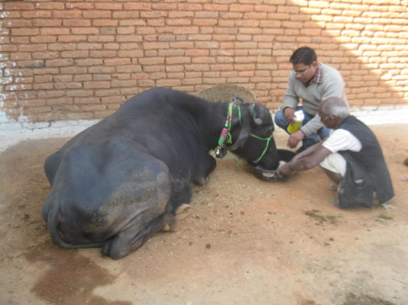 | 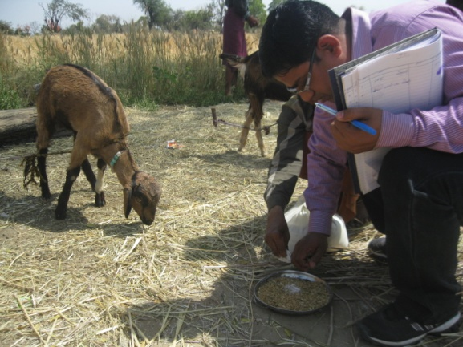 | 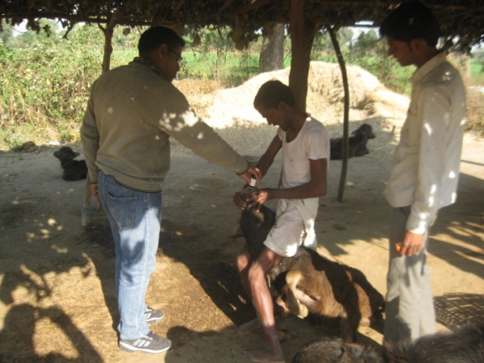 | 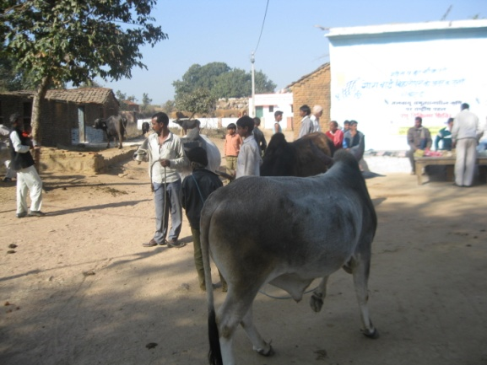
Calcium supplementation -OFT | Demonstration of Lime stone powder | Demonstration on Piperazine | Animal health camp
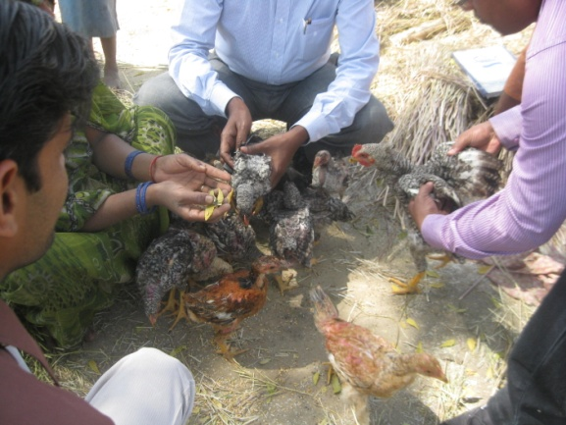 | 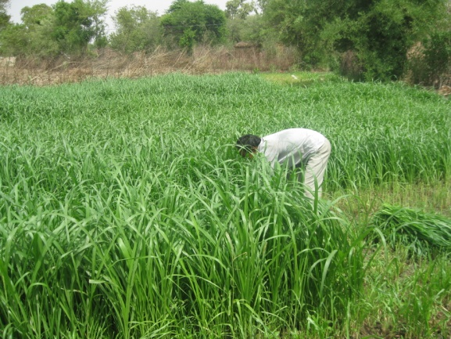 | 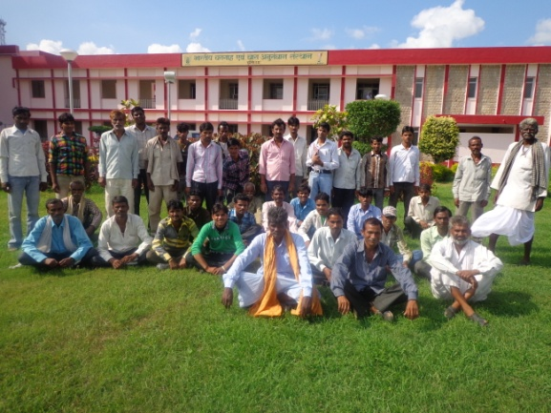 | 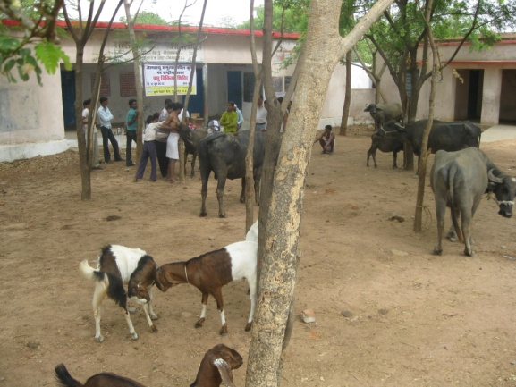
Backyard poultry farming | Demonstration of green fodder Jowar | Exposure visit of farmers to IGFRI | Animal health camp

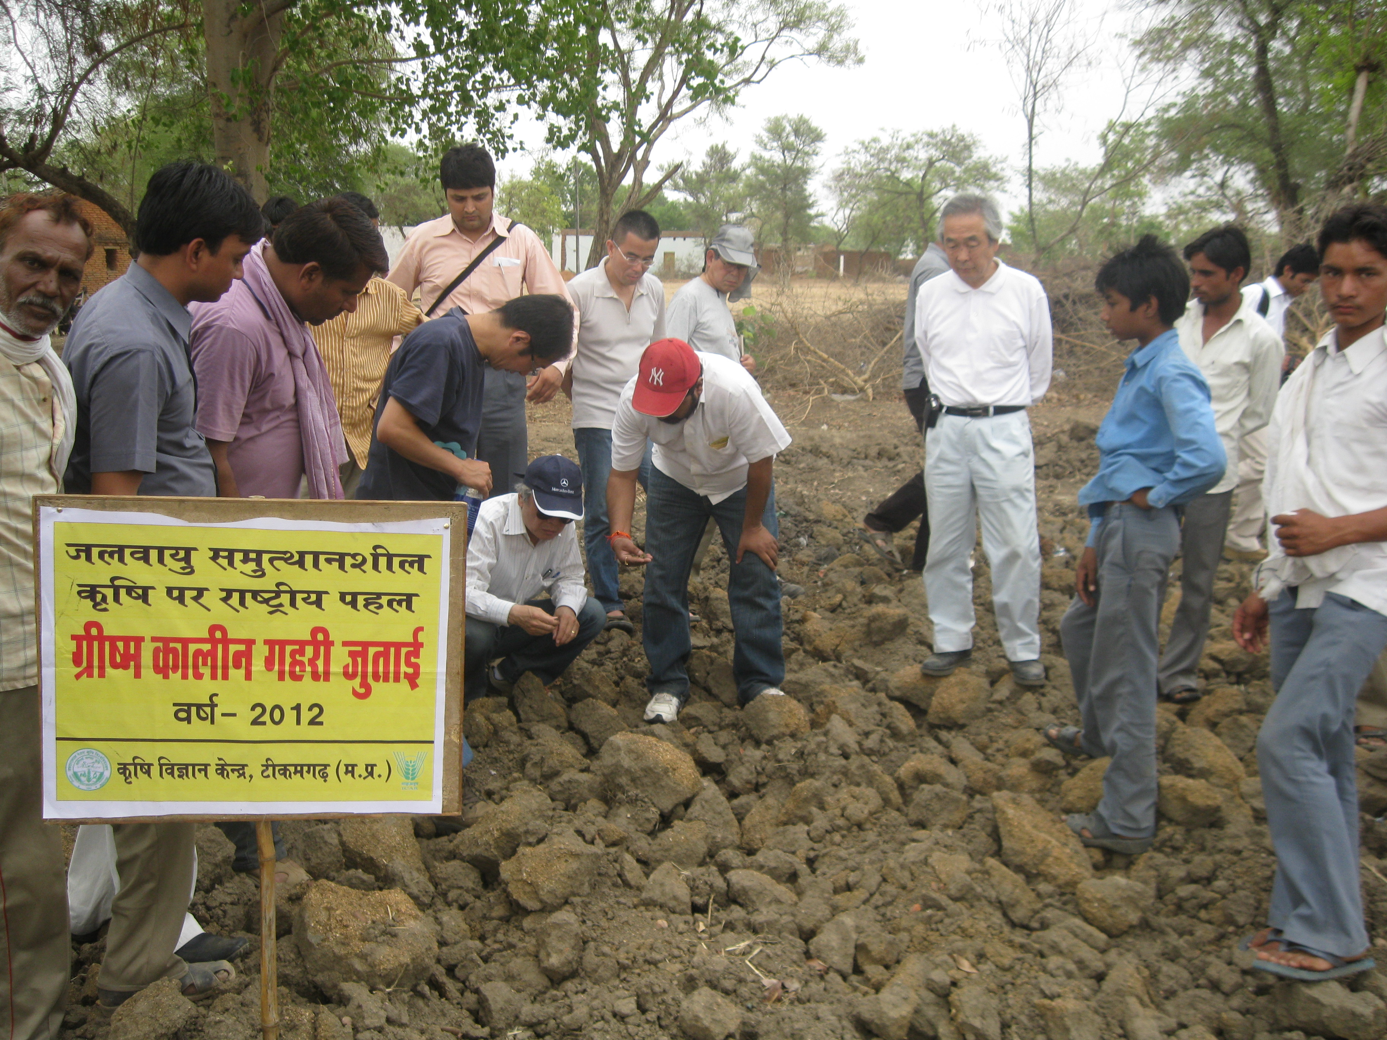 | 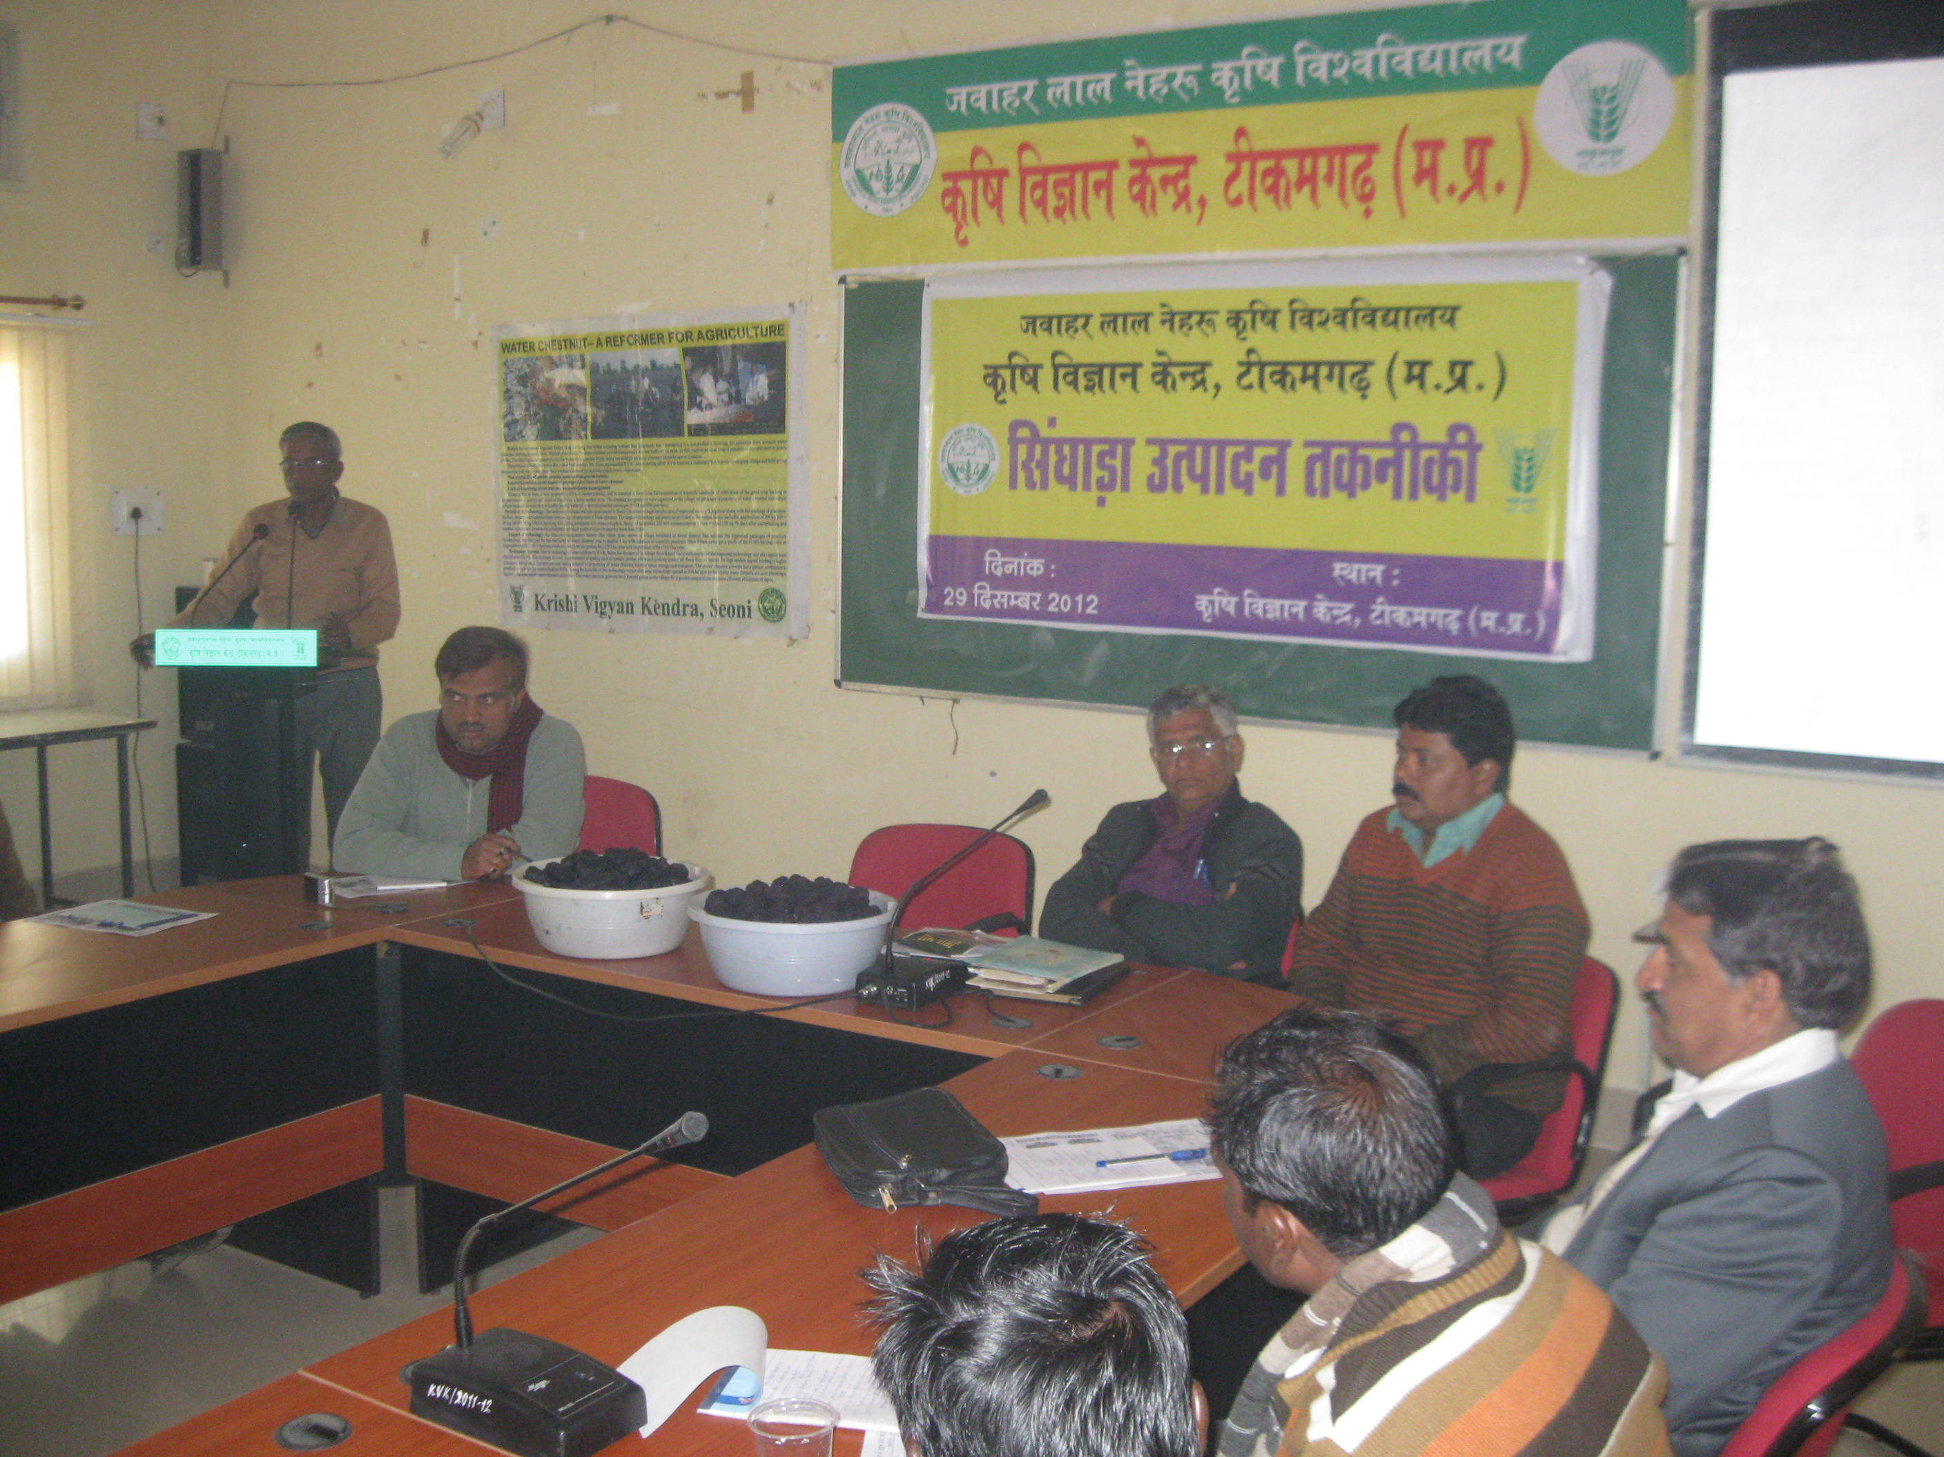 | 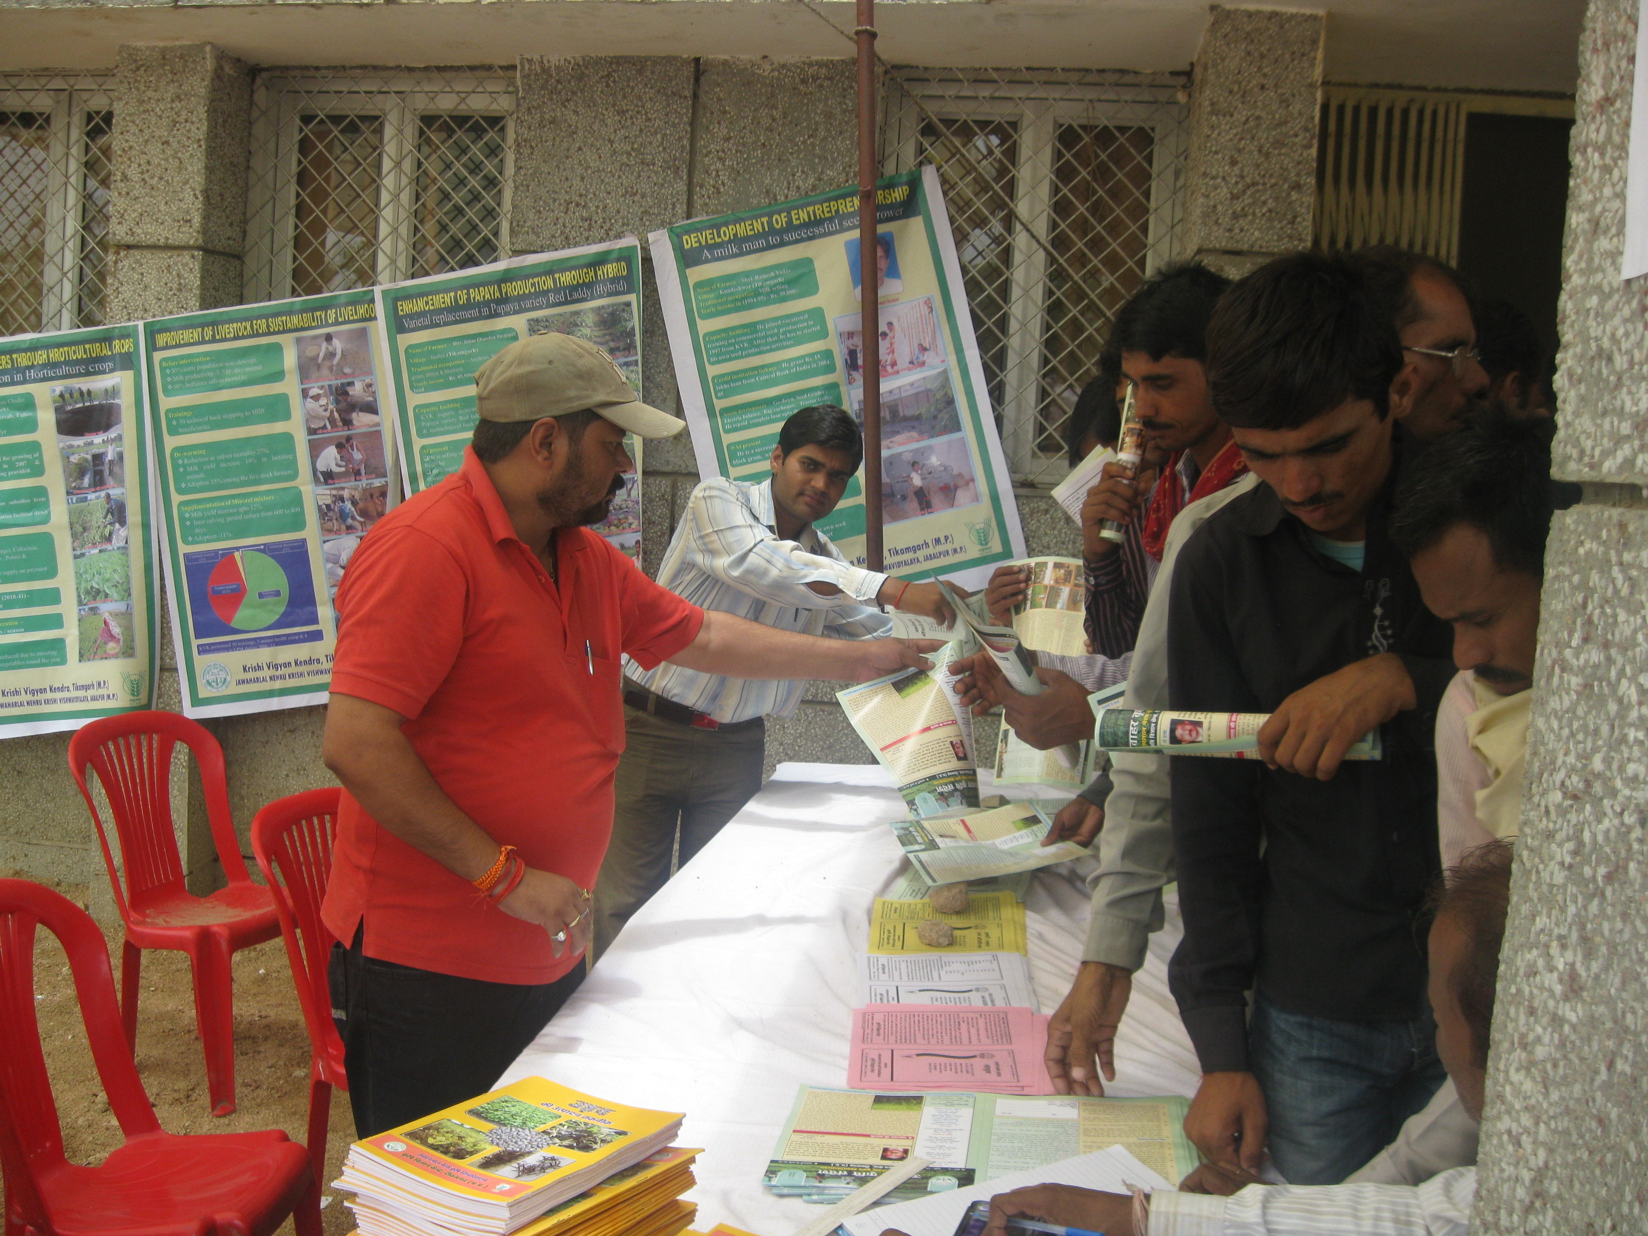 | 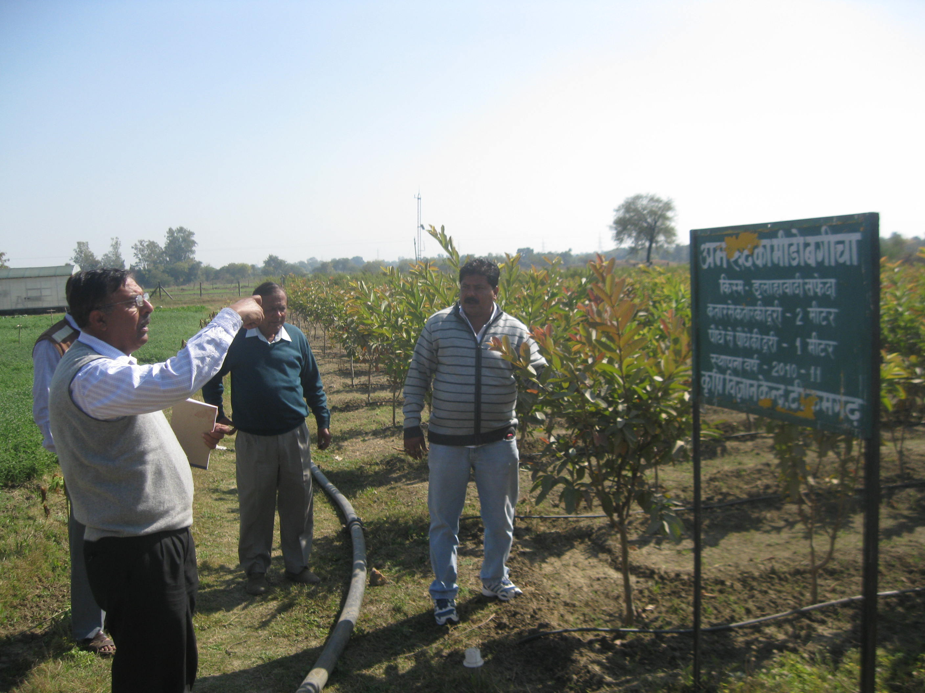
Japanese Visit in Adopted Vill. | Water Chestnut Training | Kishan Mela, at KVK, Tkg. | Dr. B.K. Karkay , NHB, at KVK
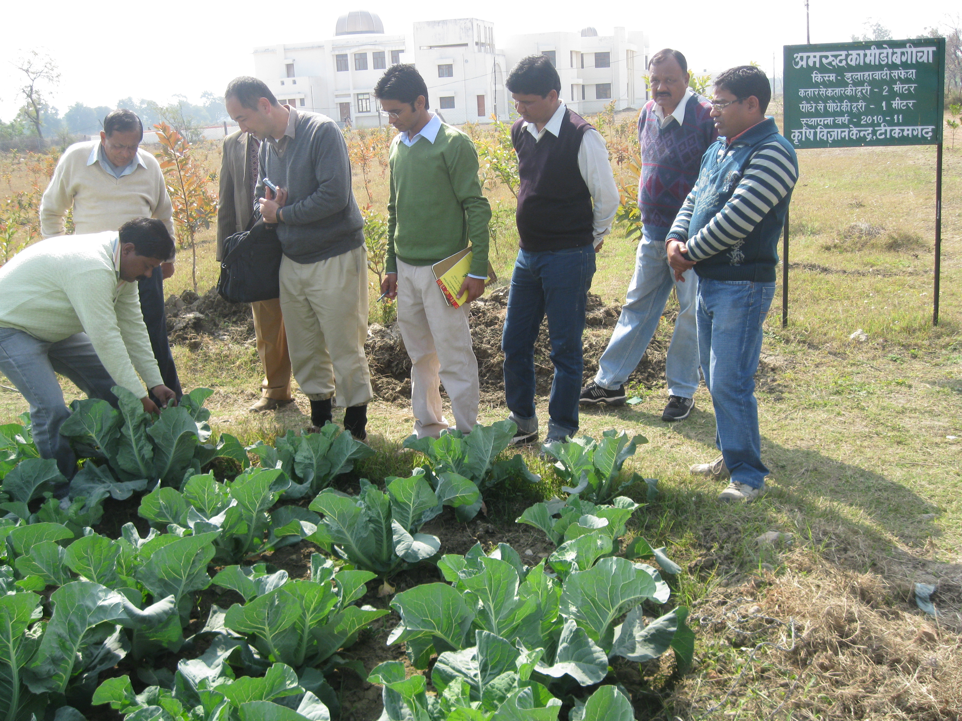 | 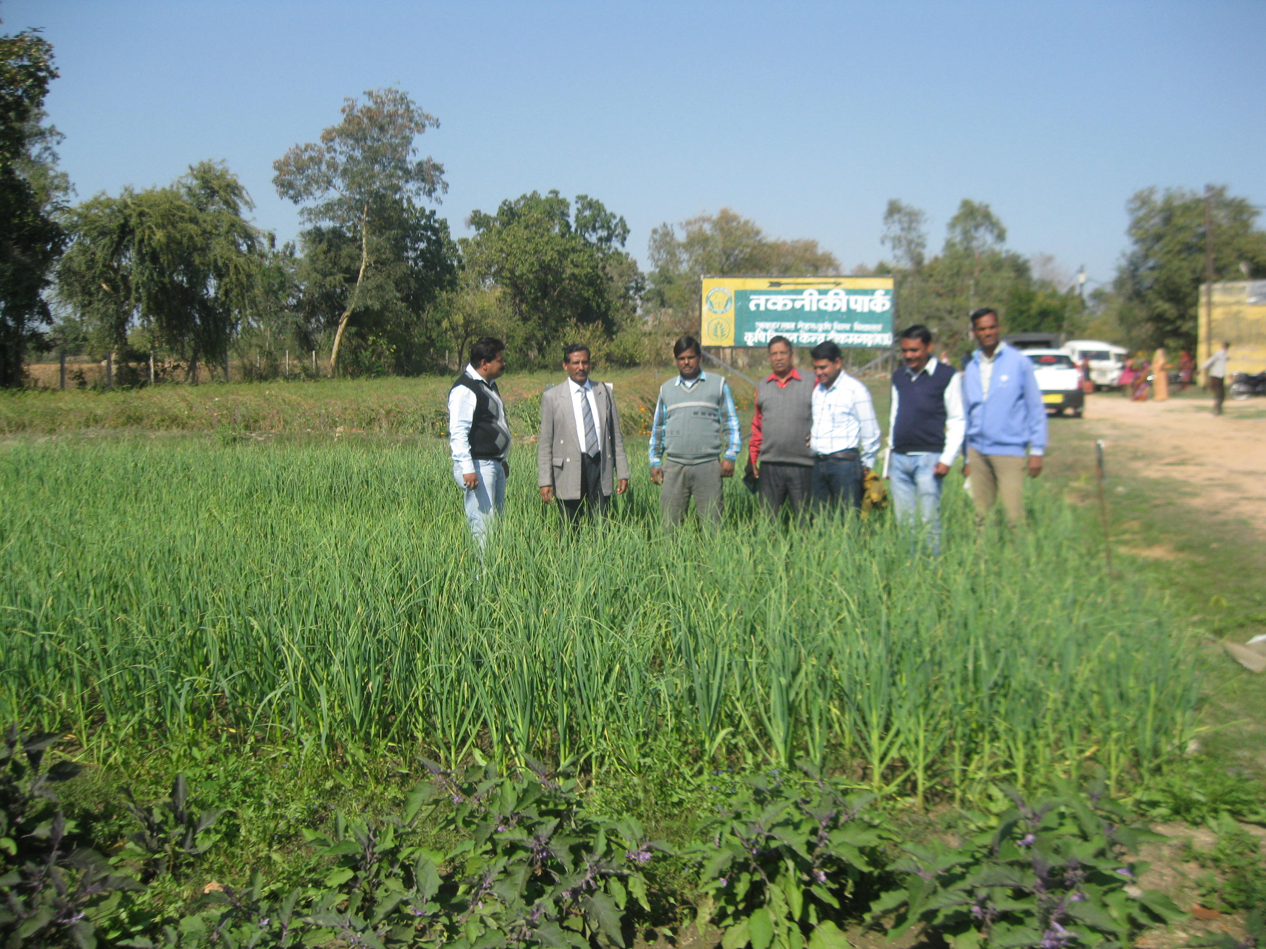 | 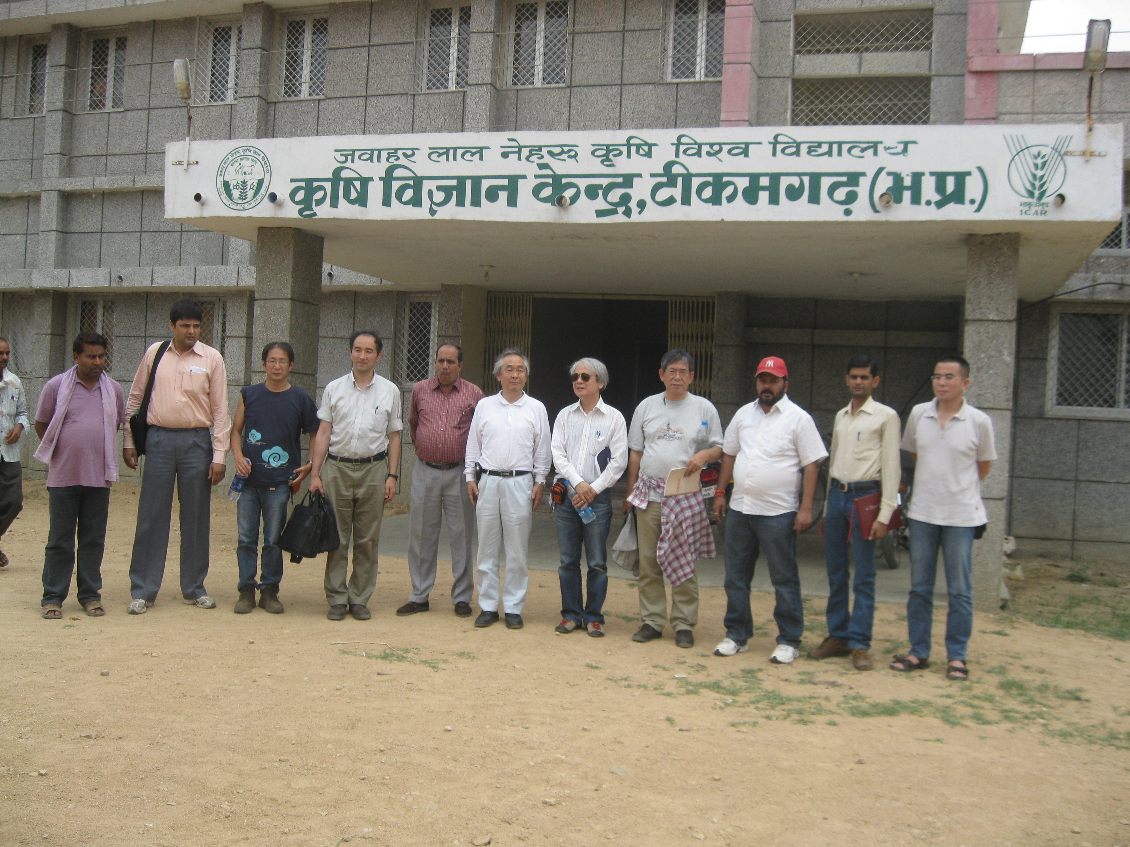 | 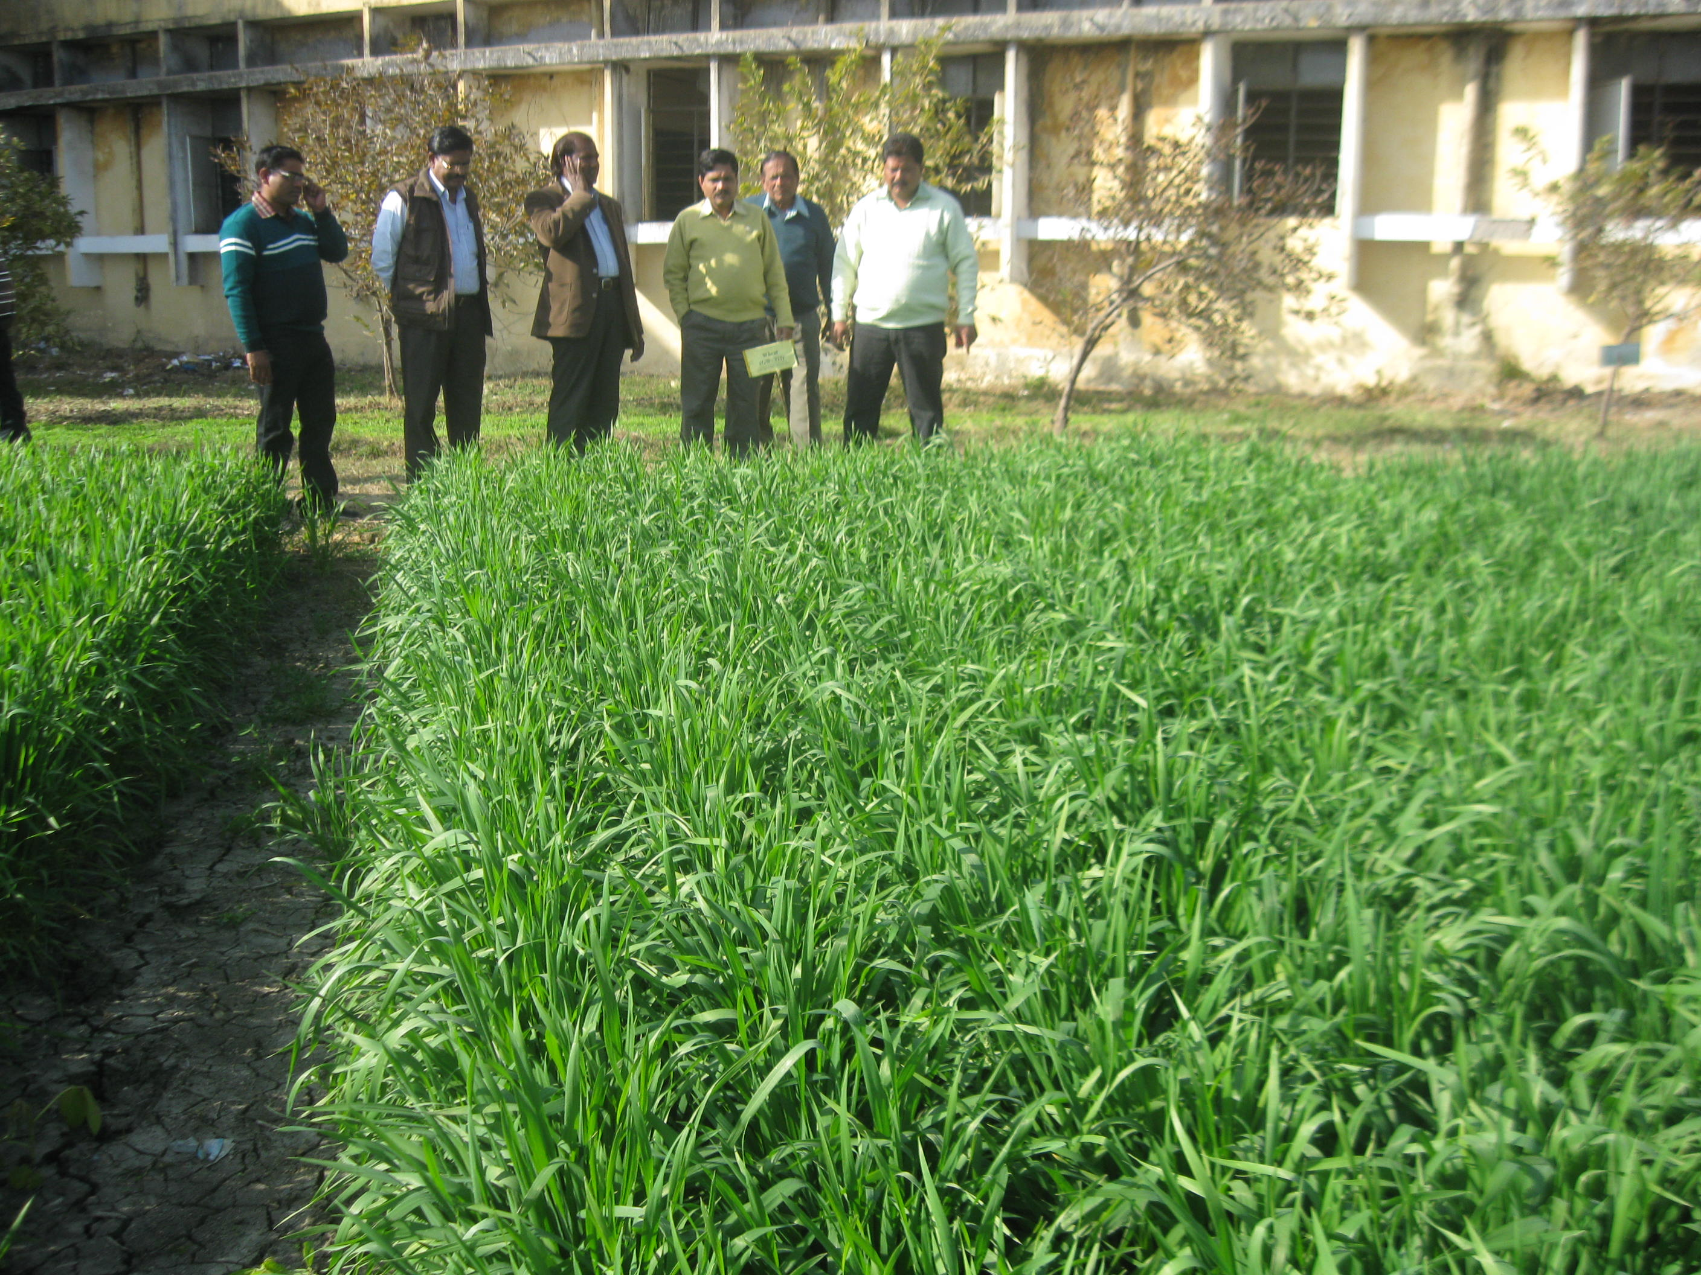
Field Visit at KVK Tkg | Cafeteria visit of Dr.K.P.S.Malik | Japanese visit at KVK, Tkg | Sri B.M. Saharay , JDA, Bhopal
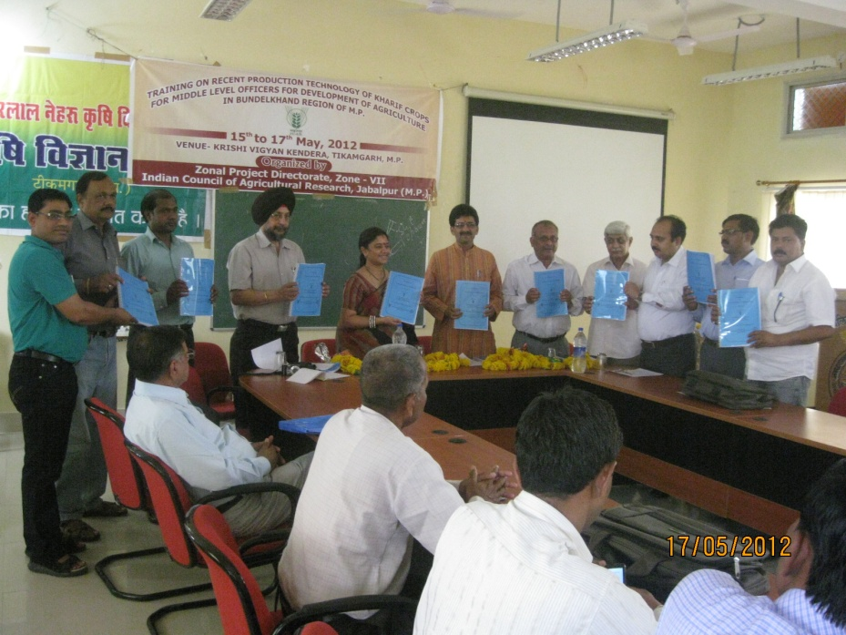 | 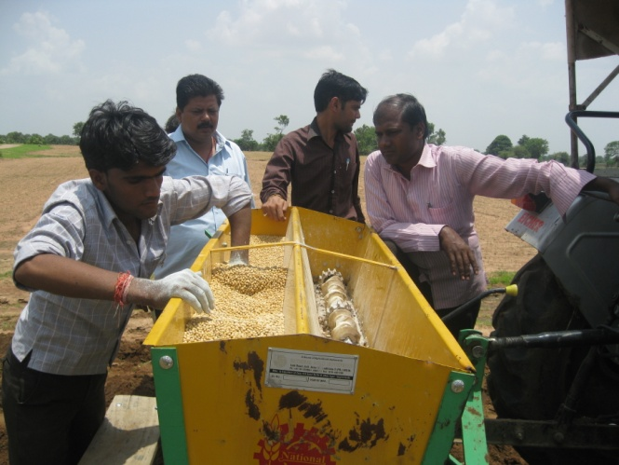 | 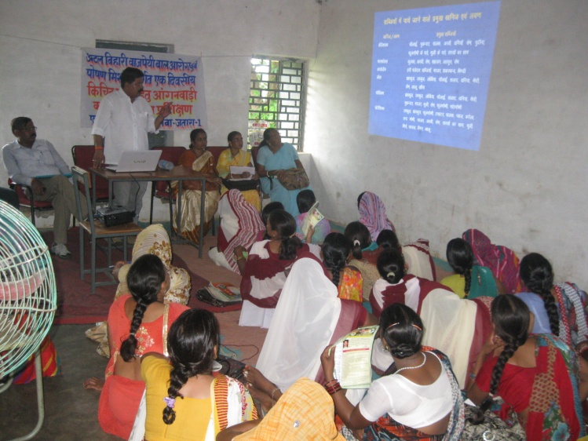 | 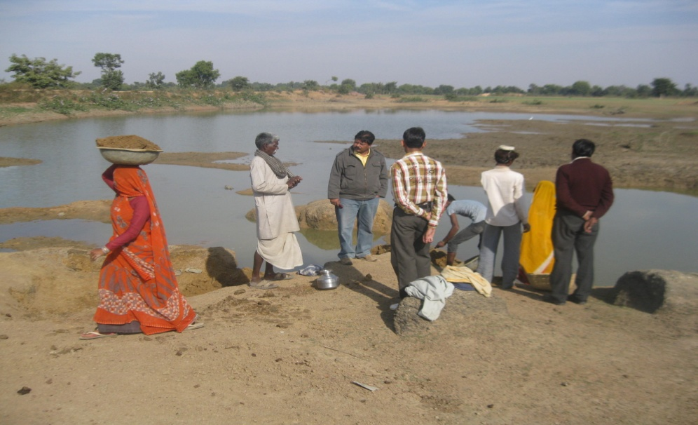
Dr. R.S.Saini, Planning Commission at KVK Tkg | Scientist on Farmer Field | Aganbadi Training | Work of Desalting at Adopted Village

